Bioengineering Devices Lab 3D Vessel Cleaner

Final Report

Steven Schwartz II
Milo Gubler
Mason Minitti
Muath Nasrallah

Spring 2022 – Fall 2022

[Insert NAU or Team Logo as watermark or include a photo of the team or project]

Project Sponsor/Advisor: Tim Becker, PhD
Sponsor Mentor: Mana Alyami
Instructor: David Willy

DISCLAIMER
This report was prepared by students as part of a university course requirement. While considerable effort has been put into the project, it is not the work of licensed engineers and has not undergone the extensive verification that is common in the profession. The information, data, conclusions, and content of this report should not be relied on or utilized without thorough, independent testing and verification. University faculty members may have been associated with this project as advisors, sponsors, or course instructors, but as such they are not responsible for the accuracy of results or conclusions.

EXECUTIVE SUMMARY
The aim of this project is to create a fluid-based cleaning system capable of thermal and pneumatic control to prevent damage when removing support material (SM) from 3D-printed neurovascular models. This system can help the Bioengineering Devices Lab (BDL) prepare Circle of Willis (CW) and Delayed Aneurysm Rupture (DAR) models for prototyping various medical devices. Models are pre-treated with 0.5 mol. Sodium Hydroxide (NaOH) for 1-2 hours prior to cleaning. The system applies cyclic fatigue to the support material at a maximum pressure of 230 mmHg using water at a maximum temperature of 49 degrees Celsius. Results demonstrate that pressure and temperature aid the clearing process, but the initial breakdown significantly depends on NaOH absorption time. Results also show that the current system can clean a Circle of Willis model within 4 hours, and a single channel model roughly 2 hours after NaOH absorption. Further, the variable output of the pump also enables the user to clean models with different wall-thickness. Overall, this method can effectively clean in-vitro models while minimizing the risk of damage.

ACKNOWLEDGEMENTS

All financial and physical resources such as equipment and lab space were provided by Dr. Tim Becker and the Bioengineering Devices Laboratory.
Husain Sodawalla, Mana Alyami, and Jesse Wells provided Vessel prints for model testing.
Glenn D’Silva, David Willy, Mana Alyami, and Tim Becker gave the group guidance throughout the project
Ryan Downey and Josette Vigil for aiding the preliminary heating system testing
[Mason’s 495 group] for aiding Head Loss
Josette Vigil additionally provided Arduino components

TABLE OF CONTENTS
DISCLAIMER 1
EXECUTIVE SUMMARY 2
ACKNOWLEDGEMENTS 3
TABLE OF CONTENTS 4
1 BACKGROUND 2
1.1 Introduction 2
1.2 Project Description 2
2 REQUIREMENTS 3
2.1 Customer Requirements (CRs) 3
2.2 Engineering Requirements (ERs) 4
2.3 Functional Decomposition 5
2.3.1 Black Box Model 5
2.3.2 Functional Model/Work-Process Diagram/Hierarchical Task Analysis 5
2.4 House of Quality (HoQ) 5
2.5 Standards, Codes, and Regulations 6
Draft National Electrical Safety Code(R) (NESC(R)) 6
3 DESIGN SPACE RESEARCH 7
3.1 Literature Review 7
3.2 Benchmarking 7
3.2.1 System Level Benchmarking 7
3.2.1.1 Existing Design #1: BioModex Cleaning Procedure 7
3.2.1.2 Existing Design #2: United Biologics Silicone Cleaning Procedure 7
3.2.1.3 Existing Design #3: BDL Current Model Cleaning Procedure 8
3.2.2 Subsystem Level Benchmarking 8
3.2.2.1 Subsystem #1: Pumping 8
3.2.2.1.1 Existing Design #1: General Pump (basic model from Amazon) 8
3.2.2.1.2 Existing Design #2: BDL Current Pulsatile Pump 8
3.2.2.1.3 Existing Design #3: Sink Spout pump 8
3.2.2.2 Subsystem #2: Heating 8
3.2.2.2.1 Existing Design #1: Hot Plate 8
3.2.2.2.2 Existing Design #2: Heating Element 9
3.2.2.2.3 Existing Design #3: Heat Exchanger 9
4 CONCEPT GENERATION 9
4.1 Full System Design #1: Compact Vessel Cleaner Alpha 9
4.2 Full System Design #2: Compact Vessel Cleaner Beta 10
4.3 Full System Design #3: Compact Vessel Cleaner Gamma 10
5 DESIGN SELECTED – First Semester 11
5.1 Design Description 11
5.1.1 Proposed Design 11
5.1.2 Changes Made during Prototyping 11
5.1.3 Engineering Calculations 11
5.2 Implementation Plan 11
6 Project Management – Second Semester 13
6.1 Gantt Chart 13
6.2 Purchasing Plan 13
6.3 Manufacturing Plan 13
7 Final Hardware 15
7.1 Final Hardware Images and Descriptions 15
7.2 Design Changes in Second Semester 17
7.2.1 Design Iteration 1: Change in Pump System discussion 17
7.2.2 Design Iteration 2: Change in Water Reservoir discussion 17
7.2.3 Design Iteration 3: Change in Heating System discussion 17
7.2.4 Design Iteration 4: Change in Connectors discussion 18
7.3 Challenges Bested 19
8 Testing 20
8.1 Testing Plan 20
8.1.1 Experiment 1 – Filter Capacity 20
8.1.2 Experiment 2 – Model Failure Pressure 20
8.1.3 Experiment 3 – Model Deflection 20
8.1.4 Experiment 4 – Sodium Hydroxide Pretreatment TIme 20
8.1.5 Experiment 5 – Minimum Model Cleaning Time 21
8.2 Testing Results 21
9 RISK ANALYSIS AND MITIGATION 23
9.1 Potential Failures Identified First Semester 23
9.1.1 Potential Critical Failure 1: Mesh Filter Blockage 23
9.1.2 Potential Critical Failure 2: Pump Damage due to Support Material 24
9.1.3 Potential Critical Failure 3: Water surpasses max temperature 24
9.1.4 Potential Critical Failure 4: Excess Pump Flow 24
9.1.5 Potential Critical Failure 5: Short-Circuited Heating Element 24
9.1.6 Potential Critical Failure 6: Short-Circuited Pump 24
9.1.7 Potential Critical Failure 7: Overheated Pump 24
9.1.8 Potential Critical Failure 8: Thermal Fatigue on Pump 24
9.1.9 Potential Critical Failure 9: Air-Induced Pump Damage 24
9.1.10 Potential Critical Failure 10: Heating Element Damage 24
9.2 Potential Failures Identified This Semester 27
9.3 Risk Mitigation 28
10 LOOKING FORWARD 28
10.1 Future Testing Procedures 28
10.2 Future Iterations 29
11 CONCLUSIONS 29
11.1 Reflection 29
11.2 Resource Wishlist 30
11.3 Project Applicability 30
12 REFERENCES 31
13 APPENDICES 32
13.1 Appendix A: Functional Decomposition Model 32
13.2 Appendix B: House of Quality 33
13.3 Appendix C: Engineering Analysis - Head Loss 34
13.4 Appendix D: Gantt Chart 35
Table C. Gantt Chart 35
13.5 Appendix E: Bill of Materials 40
13.6 Appendix F: Arduino Electrical Schematic 43
13.7 Appendix G: Specification Sheets 44
13.8 Appendix H: Failure Modes Effect Analyses 48
13.9 Appendix I: Descriptive Title 54

BACKGROUND

Introduction
The Bioengineering Devices Lab (BDL) In-Vitro flow model is a Circle of Willis model meant to simulate the physiological conditions of human brain vasculature subjected to aneurysms, which makes it suitable for device deployment prior to In-Vivo (within the body) testing and treatment. Due to similarities in material properties, the vasculature model is created from three-dimensional (3D) printed materials. The objective of this project is to develop a Compact Vessel Cleaning (CVC) pump-system to efficiently clear out the 3D support material.

The BDL specializes in biomaterials research and aneurysm treatment/prevention [1], which makes the flow model an important cornerstone of their research. Therefore, this system is needed for the effective replacement of any damaged or expired Circle of Willis models. The sponsor of the project is Dr. Tim Becker, the BDL’s Principal Investigator (PI), who is the primary stakeholder of this project. However, the stakeholders with the greatest risk are victims of stroke. According to the Brain Aneurysm Foundation, 500,000 people die from brain aneurysms each year, and roughly 66% suffer from long-term neurological deficit [2]. The World Health Organization also suggests that stroke (also caused by aneurysms) is the second leading cause of death worldwide [3].

Project Description
The scope of this project is to design, build, and test a compact cleaning system for 3D models. This system will provide an efficient way of cleaning 3D models. The goal is to develop a simple design, easy to use, and portable.

REQUIREMENTS
The requirements were provided by the customer which were the list of specifications. Those requirements are provided in more detail in section 2.1. The engineering requirements were firstly set for ensuring compliance with the specifications set by the customer. The measurable specifications to each requirement was established.

Customer Requirements (CRs)
The customer requirements reflect the qualitative objectives associated with a project. With the exception of cost and some physical dimension, these requirements are based on non-engineering qualities as listed below.

- CR 1 - Water Pump: Water Pump is needed to apply pressure to the Support Material.
- CR 2 - Water Heater: Water needs to be heated to cause thermal expansion for the support particles.
- CR 3 - Heat On/Off: A switch that activates/deactivates the system.
- CR 4 - System On/Off: A switch that activates/deactivates the system.
- CR 5 - Fast Cleaning: System needs to clean models within a day.
- CR 6 - Water Reservoir: To keep water stored while the system is running.
- CR 7 - Mesh Filtration: To remove support material from the water, the mesh should be detachable to clean the system.
- CR 8 - Multiple Cleaning Cycle before Filtration Replacement: Filter should be able to hold the equivalent of 10 circles of Willis cleaning cycle worth of support material prior to removing the filter.
- CR 9 - Universal Connectors: To clean models with varying inlet/outlet quantities.
- CR 10 - Adjustable Pressure: Output pressure should be adjusted by the user to ensure high cleaning efficiency without damaging the vessels.
- CR 11 - Compact Design: Design needs to fit within constraints provided by the client.
- CR 12 - Pulsatile/Constant Flow Control: To change between high-pressure vs. high-flow rate.
- CR 13 - Automated Pressure Regulation/Pressure Alert System: System either needs to be completely automated throughout the cleaning process or needs
  - the system is currently optimized for a pressure alert system
- CR 14 - Temperature Measurement: To adjust/measure temperature during cleaning cycle.
- CR 15 - Pressure Measurement: To measure pressure during cleaning cycle for adjustment.
- CR 16 - Clean Models: System should be able to independently clean at least 95% of support material within the vessel structure with the only aid being Sodium Hydroxide for Pre-treatment.
- CR 17 - Unruptured Models: Pressure output from the system should not cause damage to the vessels during the cleaning process.
- CR 18 - Undeformed Models: Temperature output from the system should not cause heat deflection of the vessel framing during the cleaning process.

Engineering Requirements (ERs)
The engineering requirements reflect the quantitative objectives associated with a project. Some requirements were provided by the client, while others required additional meetings to establish.

- ER 1 – Working Water Temperature: Minimum Water Temperature needed for model cleaning.
- ER 2 – Flow Rate: Minimum Flow Rate needed to deliver support material to the filter.
- ER 3 – Working System Pressure: Minimum Water Pressure needed for model cleaning.
- ER 4 – Reservoir Volume: Minimum Volume needed to supply water to the system during the cleaning process.
- ER 5 – Support Material Filter Capacity: Maximum Mass that occupies the filter prior to replacement.
- ER 6 – Heating Voltage: Voltage needed to power the heating element.
- ER 7 – Pump Voltage: Voltage needed to power the peristaltic pump.
- ER 8 – System Dimensions: Volume that the system occupies.
- ER 9 – Cleaning Time: Time needed to completely clean a vessel (Excluding NaOH Pretreatment).
- ER 10 – Pressure Gauge Resolution: Least Significant Digit needed to measure Pressure.
- ER 11 – Temperature Gauge Resolution: Least Significant Digit needed to measure Temperature.
- ER 12 – Filter Minimum Mesh Size: Mesh length needed to filter out undissolved support material from water.
- ER 13 – Pulse Frequency: Number of cycles per second required to supply the most efficient output pressure.
- ER 14 – Signal Response Delay: Time interval between notification signals to prompt users when maximum pressure has been exceeded.
- ER 15 – Vessel Model Port Count: Number of ports needed to clean models with varying inlets/outlets.
- ER 16 – Proximal-Distal Pressure Differential: Change in Inlet to Bypass (Outlet) pressure that varies between a clean model and an unclean model – unclean models will have larger pressures at the inlet.
- ER 17 – Maximum Water Pressure: Maximum pressure that does not rupture vessels – will be used to notify the user if vessel damage may occur.
- ER 18 – Maximum Water Temperature: Maximum water temperature that does not cause vessel frame deformation.

Functional Decomposition
Due to the customer requirements, there have been no changes made to the black box or functional decomposition model since the last report.

Black Box Model
Based on the Customer Requirements discussed in Chapter 2.1, the inflows and outflows were simplified using a black box model in Figure 1. The bold arrows represent the materials, the light-weight arrows represent the system’s energy, and the dashed arrows represent the signals throughout the system. The arrows pointing toward the black box are the inflows (materials, signals, energy) going into the system. The arrows pointing away from the box are the outflows. The overall objective of the black box is represented by the text within the box. The black box model aided the team in developing a more advanced breakdown, known as the Functional Decomposition model in Section 2.3.2.
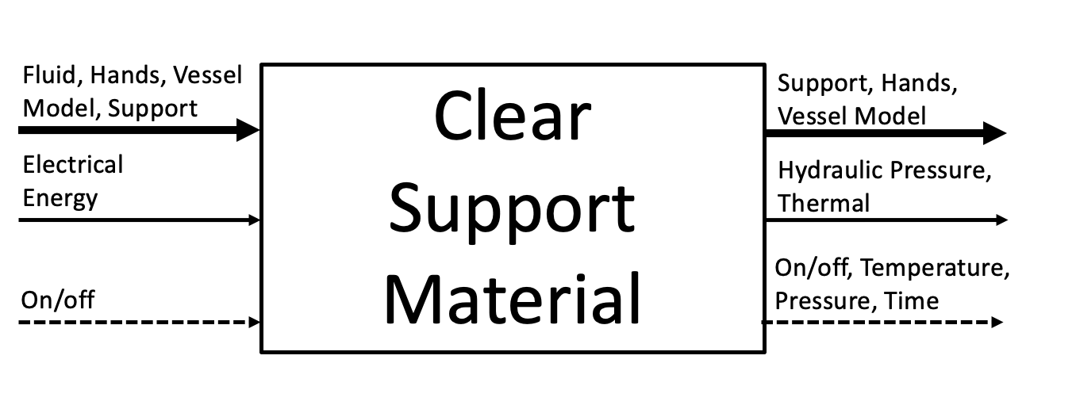
Figure 1: Black Box Model

Functional Model/Work-Process Diagram/Hierarchical Task Analysis
Due to the array of various processes throughout the system, a simple flowchart would not suffice. Using the black box model in Chapter 3.3.1, a Functional Decomposition model was developed (see Appendix A). The functional decomposition model uses the same notation as a black box model, but creates a breakdown of each step throughout the device’s process. Each step was conceived from the customer requirements and the preliminary vessel cleaner design. Using the functional decomposition, the team created several preliminary designs for their concept generation phase in Chapter 4.

House of Quality (HoQ)
The “house of quality” (HoQ), (Appendix B), is used to relate the customer requirements (CR) and the engineering requirements (ER). The CR are each given a weight/importance score, this score will help the team balance the final score to ensure the clients most desired or attainable requirements are sure to be met. When comparing the CR and ER the values 1, 3, 9 are used to quantify the relationships, a blank space means that there is no relationship between the two requirements. A 1 represents a weak relationship between the requirements, a 3 represents a moderate relationship between the requirements, and a 9 represents a strong relationship. One strong relationship in the HoQ is the CR for fast cleaning and the ER maximum system pressure, this is because at the maximum pressure then the fastest cleaning will occur as well as the case that if the system is at a very low pressure then the cleaning time will be long. The HoQ also compares the effects of each ER on the others. For example, as flow rate increases it will cause water pressure to increase. The HoQ also compares the project to other companies methods for cleaning 3D printed vessels. These comparisons and relationships were used during the design process to brainstorm and develop a system that would meet all CR/ER. One specific example of this process is in relation to the selection of a data acquisition system. Considering CR 12 and CR 16 the decision was made to use an arduino based pressure reading system instead of a LabVIEW pressure reading system to accommodate for CR 12 which is the desire for a compact design. The LabView system would need to be connected to a computer which would not be a compact design nullifying CR 12.

Standards, Codes, and Regulations
To develop a safe and efficient design, the team will use a set of standards and regulations as listed in Table 1. IEEE/ 13.26029.020 will be used to protect the users from harm caused by use of electricity. IEEE/ Standard 2700-2014 provides a consistent framework for sensor performance specification vocabulary, units, circumstances, and limits. 10.1109/IEEESTD.1975.81090 gives standards for the application of temperature-measurement techniques in monitoring the operating temperature and temperature rise of commonly used electrical machines, instruments, and apparatus.

Table 1: Standards of Practice as Applied to this Project
Standard Number or Code | Title of Standard | How it applies to Project
IEEE/ 13.260 29.020 | Draft National Electrical Safety Code(R) (NESC(R)) | Electrical Safety Precautions are needed to minimize risk when manufacturing this device.
IEEE/ Standard 2700-2014 | Standard for Sensor Performance Parameter Definitions | Helps in measuring the performance of our project design.
10.1109/IEEESTD.1975.81090 | Recommended Practice for General Principles of Temperature Measurement as Applied to Electrical Apparatus | Helps in temperature measurements in this project.
ASTM F444-88 | Standard Consumer Safety Specification for Scald-Prevention Devices and Systems in Bathing Areas | Heating Safety Precautions are needed to minimize risk when operating this device

DESIGN SPACE RESEARCH

Literature Review
The most prominent source that was used for benchmarking and design research was evaluating similar systems. There were two model cleaning procedures used by BioModex and United Biologics that were evaluated in the design research as well as the BDL procedure for cleaning models. Another source that was used for benchmarking and design research was literature. The main literature that was reviewed was about fluid dynamics and the heating element. These were researched to learn about how the fluid would move in the system and what the expected losses would be in the system. The literature about the heating element was reviewed to see how much power would be needed to heat the system as well as finding the best method to control the heating element. As the development of the project continued, the heating element was replaced by a Polystat Heat Bath and therefore the initial literature was not as important. The use of Arduino forums, schematics, and web searches were also used as sources during this project to develop the code and wiring necessary to complete the electronic portion of the project.

Benchmarking
System level benchmarking was done by conducting research of other companies' cleaning methods. Subsystem level benchmarking was done by researching the possible components of our system that would be used. An important part of the research was evaluating how each potential component would satisfy the engineering requirements and customer requirements of the project. Some problems that benefited from the initial benchmarking study were pump selection and heating selection. The pump selection was helped by the benchmarking because the research showed that two types of pump would be needed to satisfy the ER and CR’s. Similarly the initial benchmark study of the potential heating methods were a great way to start the process to find a solution of how to heat the water in the system.

System Level Benchmarking
The main requirements relevant to the full system level that were evaluated during benchmarking were fast cleaning, compact design, and automated components. For example, all of the designs that were benchmarked had a mostly manual cleaning procedure, meaning that the design chosen should try to be mostly automated.

Existing Design #1: BioModex Cleaning Procedure
The company BioModex uses a hand cleaning method for the majority of their cleaning processes. BioModex also creates 3D printed models for Bio Realistic Haptic Simulators. This research was on the company 3 years ago. The company only briefly described their cleaning of support material out of the vessel models by describing a method of mostly hand cleaning with wire brushes and hot water, or using an undisclosed chemical to dissolve the support material. BioModex most likely uses a more developed system currently but the information is proprietary. This method is similar to the current BDL method because the BDL lab currently uses a pulsating pump along with a hand cleaning method.

Existing Design #2: United Biologics Silicone Cleaning Procedure
This company uses a different method for cleaning because the vessel models are not 3D printed. The company uses a chemical and a hand cleaning method to clean the silicon models. Methods from this company are applicable because after the support material is removed from our system the vessels can still be cleaned using our system. This company does not disclose the chemicals they use and they do not disclose whether or not they use an automated system.

Existing Design #3: BDL Current Model Cleaning Procedure
The current method that the BDL uses to clean the models is mostly done by hand. The lab uses NaOH and a peristaltic pump connected to a standard lab sink to do the cleaning. This method has many setbacks because the pressure is not displayed which could lead to a rupture in the model. Also, when cleaning the models by hand the model is subject to potential rupture.

Subsystem Level Benchmarking
The two subsystems that were benchmarked were the pump and the heating system. These two subsystems were chosen because two of the highest importance ER and CR are the temperature and pressure of the system. These two functions are the main systems that will clean the model. The design decision for these two systems will also affect the cleaning time, overall size of the design, and the ability to automate the components.

Subsystem #1: Pumping
This subsystem will control the flow of fluid through the system. The pump that is desired by the customer requirements should have pulsatile capabilities. The pump will control the flow rate and have a strong correlation to the max water pressure engineering requirement and target value.

Existing Design #1: General Pump (basic model from Amazon)
A general pump will fulfill the requirements of being able to control the pressure and flow rate. This will not be a pulsatile pump therefore will not meet the customer requirement. This pump will be purchased from a third party.

Existing Design #2: BDL Current Pulsatile Pump
This pump is the current method of pumping in the BDL lab. The pump is connected to a wall near the water outlet in the lab. The pump is then connected to the vessel model after the vessel has been cleaned by hand. The pulsatile pump then pumps uncontrolled hot water through the vessel to remove the final support materials. This method is not autonomous and cannot be turned off if the pressure gets too high it must be personally monitored. This pump matches the customer requirements of being pulsatile. The controls of the flow rate have not been tested to see if they will match to our project design. This pump may be used in our project if we need/desire. This pump in our project will be improved by adding control systems to make the system autonomous.

Existing Design #3: Sink Spout pump
This design is a method of using the flow out of general buildings as the pump. This method is not good for pressure control because the water coming out of the sink can not be controlled well. This also will not lend itself to the customer requirement of being temperature controlled. This method also can not be controlled to be a pulsatile pumping method. This is not a conventional pump but it was good to benchmark this as a method because it is a possible method in powder to keep the cost down by not having to purchase a pump.

Subsystem #2: Heating
This subsystem controls the temperature of the fluid. As desired by the customer in engineering requirements, the maximum temperature should be 80°C.

Existing Design #1: Hot Plate
This design is a simple water tank that sits on a hot plate. The primary advantages of this design are the pre-designed circuit and temperature setting with on/off switch. The disadvantages of this design are the price, limitations on insulation and safety precautions, and size of the system. With a very small height limitation, placing a small container on a hot plate while surrounding the system with insulation and a protective layer is no longer feasible.

Existing Design #2: Heating Element
This design utilizes a small heating element that can be found in a household water heater. It allows for more consistent heating, and connecting a voltage transducer to the circuit can regulate the temperature output. Another advantage is the ability to fully insulate the heating tank and cover it in a protective layer without exceeding the height requirements. The disadvantage to this design is the need to design a circuit that meets the general requirements for any circuit to be connected to a standard 120V wall outlet.

CONCEPT GENERATION

Full System Design #1: Compact Vessel Cleaner Alpha
This design was the proposed design for Spring 2022. The process of making this design included compiling the designs for the different subsystems in a way that would hypothetically meet all the design requirements. This design was used as the blueprint for the product however, there are many differences between this design and the true final hardware of the product. The proposed design used a sphygmomanometer to read pressure and had a wooden frame. The changes include: framing, data acquisition, heating element, and the custom mesh filter. The current hardware uses a steel wire frame, an arduino assisted pressure transducer based control/monitoring, and custom mesh filter has no collection unit. Finally, the heating element was completely replaced by a Polystat Heat Bath.
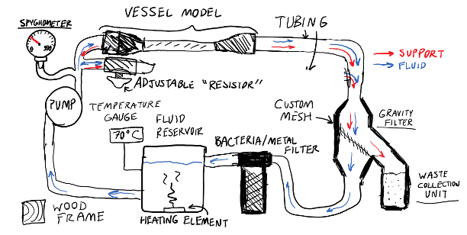
Figure 2: Compact Vessel Cleaner Alpha Design

Full System Design #2: Compact Vessel Cleaner Beta
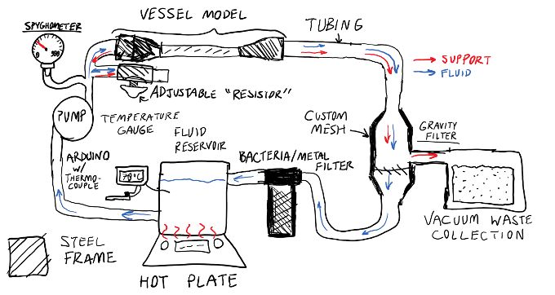
Figure 3: Compact Vessel Cleaner Beta Design

Full System Design #3: Compact Vessel Cleaner Gamma

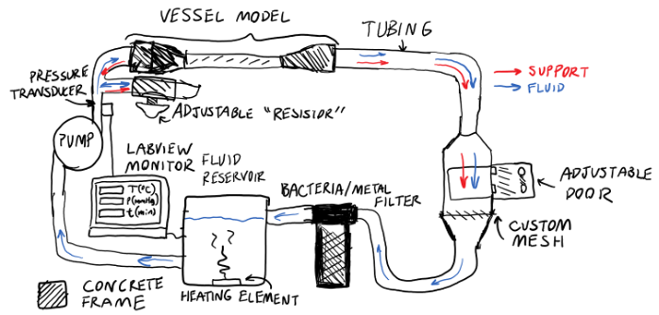
Figure 4: Compact Vessel Cleaner Gamma Design

DESIGN SELECTED – First Semester
This chapter explains the design process following the initial design throughout the first semester. Starting with several concept drawings and CAD models, the team developed a foundation for their design for their subsystems as well as their overall system design. Based on feedback from their Capstone instructor, sponsor mentor, and their client, they were able to incorporate feedback for a finalized design choice.

Design Description

Proposed Design
By developing a series of concept models, the team formulated a proposed design. The initial design features a 9 in. diameter water heating tank connected to a pulsatile pump that is already used for cleaning 3D models. After being pumped, the heated water flows through an attached model to a filter. This filtration unit features an angled mesh to contain the removed support material while the water continues to flow. The filter is separable for easy removal of the support material post cleaning. The water post filtration moves to a water reservoir that fills the heating tank. This extra reservoir allows for the water used in the closed system to be easily maintained via a fill port at the top.

Changes Made during Prototyping
Through feedback from the team mentor, the initial design was acceptable; however, the planned pump could not be used. To ensure the budget is maintained, a cheap fountain pump was considered in place of a pulsatile pump. To regulate the pressure in the system, a set of clamps will be used before the sphygmomanometer to ensure the final pressure before the model is within safe levels. For this design, the maximum sized frame was removed and the final frame will be built around the system once all parts are built.

Engineering Calculations
All engineering calculations are based on the testing procedures listed in Section 3, and can be found in Appendix D. Each of these calculations were selected based on the testing procedures formulated in the testing procedures section (Chapter 3). Further engineering calculations may have to be modified and selected depending on any further design changes later on in the device’s development.

Implementation Plan
To minimize the budget spending necessary for this project, the team utilized parts and resources from the BDL (Bldg. 88). Most of the resources included in the Bill of Materials (Appendix E) were provided by Dr. Becker within the BDL; but some resources were outsourced and purchased, such as the fountain pump and the fluid reservoir. Finally, the frame was manufactured in the BDL after the device layout was established. Mason and Steven developed an Arduino code to aid their testing procedures in section 8.1.

A comprehensive overview of all implementation activities is contained within a Gantt Chart (Appendix D). From the end of March until Week 12 at the latest, the team was prototyping and testing the device.
By developing a series of concept models (Section 4), the team formulated a proposed design. The initial design features a 9 in. diameter water heating tank connected to a pulsatile pump that is already used for cleaning 3D models. After being pumped, the heated water flows through an attached model to a filter. This filtration unit features an angled mesh to contain the removed support material while the water continues to flow. The filter is separable for easy removal of the support material post cleaning. The water post filtration moves to a water reservoir that fills the heating tank. This extra reservoir allows for the water used in the closed system to be easily maintained via a fill port at the top.

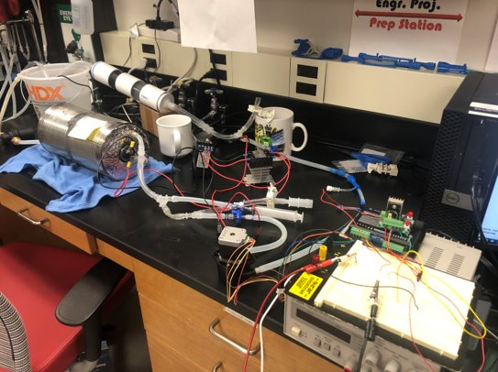
Figure 5: First Prototype

Project Management – Second Semester

Gantt Chart
Each important deliverable was added to the Gantt chart at the beginning of the semester. As the semester progressed, team members assigned to tasks changed to better fit strengths and availability of members. When the framing subsystem was added to the Gantt chart, member assignments were not made. This pushed off the designing and manufacturing of the subsystem's components. A meeting at the beginning of the semester would have helped the team to establish better deadlines for subsystems and who could work on the systems. This would have allowed the team to better coordinate a work schedule each week to complete all device subsystems more efficiently to help progress into device testing and system tuning.

Purchasing Plan
Current Plan
The current purchasing plan includes parts and tools used to make adjustments to improve system operation, and safeguard from any critical failures. These additions include the wire framing, plastic drop cloth, dual carabiners, grommets, ell and tee hose barbs, whole saws and cut-off wheels. Furthermore, the current plan includes some items from the Project management assignment such as the Peristaltic Pump.
Corrections to Previous Plan
The only corrections to the previous purchasing plan was the specification of part sizes and their prices. A list was established of what was required to complete the system, however the official parts implemented into the system, with exception to tubing, stopcocks, pumps and their driving components, were chosen just before the addition of the component. An official list of components was not developed at the beginning of the semester as the team pursued a test-driven development process. In Appendix E, Table E2 features a BOM of all items throughout the project that had been purchased.
Purchasing Plan Reflection
This allowed for more focus on the operational efficiency of the system without having to purchase too many unnecessary parts. This process aided in the success of the cleaning system, however it also pushed back the manufacturing of the framing and safety subsystems. Overall, an official purchasing plan should have been created for the secondary subsystems while all subsystems directly involved in the cleaning process remained test-driven.

Manufacturing Plan
The Manufacturing BOM can be found in Appendix E, Table D3.
Current Plan
Parts F1-5 are a part of the first filtration system. This system was built during the first semester of Capstone (476C) and has remained in the cleaning device to separate larger support material particles from the cleaning water. Parts B1-3 are the tubing used throughout the device connecting each subsystem with exception to the primary filter. Part D1 is the framing used to elevate the model and cleaning subsystems to reduce pressure loss. Parts D2-6 make up the electronics box. This box consolidates all electronic components required for operating the pressure transducers and running the peristaltic pump. An internal frame was designed and printed to organize the equipment, while the faceplate allows access to an LCD screen, operation buttons, indicator LEDs and a rotary switch. While the faceplate could allow water in, the cables run through cable glands to prevent any water from traveling along a wire into the box.
Corrections to Previous Plan
The initial manufacturing plan included a heating tank that was used during the first version of the cleaning device. The tank suffered a failure caused by over-pressurizing the system, as it didn't have a pressure relief valve and none of the air bleeds in the device were opened when additional water was added. This heating system was replaced with a heat bath with an internal pump the lab already owned.
Manufacturing Plan Reflection
During manufacturing, operation of the device was prioritized over framing. Framing was pushed back too far, and a last minute decision was made to purchase wire shelving. This forced the team to modify the wire shelving to conform to the customer's size requirements while maintaining enough of the original size to safely hold the weight of the device's subsystems. This also reduced the space for the primary filter on the frame, and adjustments to the filter's design should be made. This could be replacing the inlet and outlet barbs with L-shaped connectors, or remanufacturing the filter with smaller sections of pipe and fitting couplers and reducers completely. Similar to the framing, the finalization of circuitry was pushed off forcing the design of the electronics Faceplate and framing to be rushed. With more time for design, the Arduino, PCB, motor controller and stepper driver could sit securely with more consideration to wire lengths.

Final Hardware

Final Hardware Images and Descriptions
Figure 6 is a pump flow diagram depicting the flow of water through each component in the system.
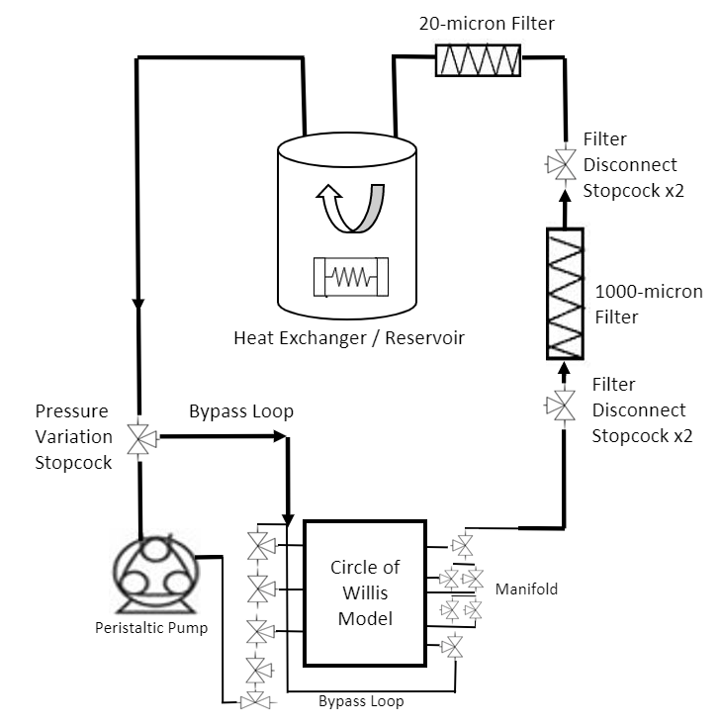
Figure 6: Pump Flow Diagram

Figure 7 is a wiring schematic for the Peristaltic pump and Stepper motor circuit.
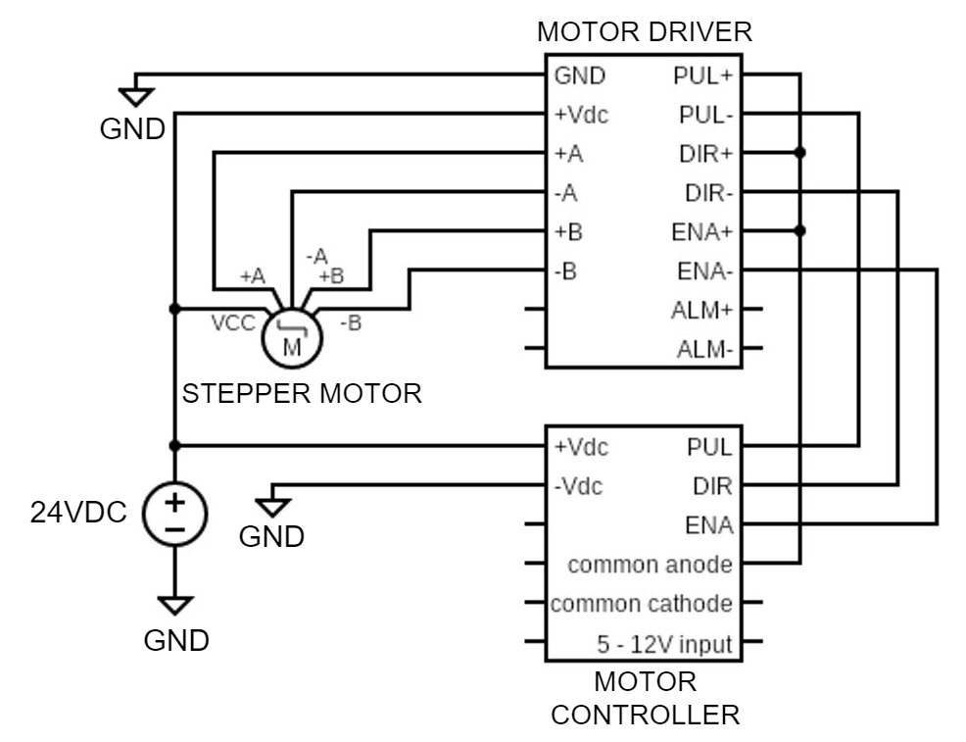
Figure 7: Peristaltic Pump; Stepper Motor Schematic

Figure 8 is a representation of the entire system in Solidworks. Each CAD part was developed and assembled by the team, with the exception of the Stopcocks, which were obtained from GrabCAD [4].
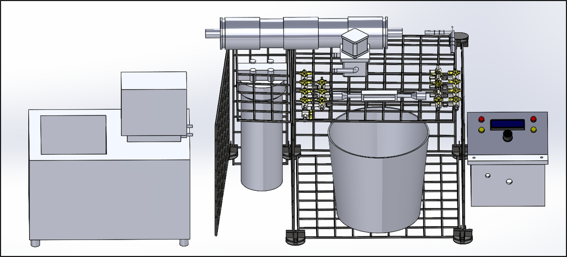
Figure 8: Final Hardware CAD

Figure 9 is a photograph of the final system design with all hardware connected.
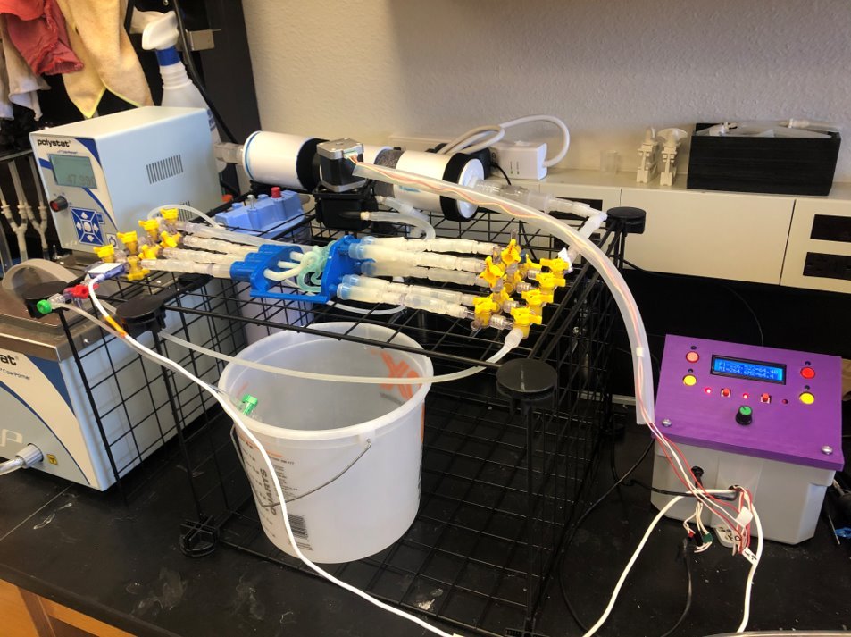
Figure 9: Final Hardware Full system

Design Changes in Second Semester

Design Iteration 1: Change in Pump System discussion
Initially the design included a Fountain Pump as the main method of supplying pressure. However, during prototyping, the non-occluded pressure output was 20 mmHg, which was significantly lower than what was needed. Furthermore, the team mentor recommended using a system with pulsatile flow. Pulsatile flow would be more effective at breaking up the SM than constant flow due to higher pressure output and dynamic loading due to the cyclic motion of the fluid. A pump controller was originally discussed as the main method of supplying flow and pressure to the vessel models. However, with further research, a peristaltic pump powered by a stepper motor could be implemented into the system. In order to control the stepper motor, a stepper motor driver and controller would be needed to control the amperage and pulse rate, respectively. These were implemented into the electronics faceplate, as it was an important part of the user interface.

Design Iteration 2: Change in Water Reservoir discussion
While the current prototype could partially clean models during 33% build, the design still had two working water reservoirs, which did not meet the dimensional requirements requested by the Client/Mentor. The first water reservoir being a 5 Quart bucket open to the atmosphere and the second being the heating element. The team had discussed removing the reservoir and making an inlet directly to the sink. However, when testing this application, the heating element ruptured, as the increase in pressure tore the bonds adjoined by JB Weld. Therefore, a new water reservoir and heating element would have to be changed in our design.

Design Iteration 3: Change in Heating System discussion
Due to the failure listed in Design Iteration 2, the team recognized that the initial heating system would not be a viable design. After discussing this failure with the client, he gave the team a Cole Parmer Polystat Heat Bath unused by the lab. This Heat Bath had an internal pump, which could move the working fluid at 3 Liters/min without the assistance of another pump. Additionally, it had a level sensor which would stop the pump if a “low-level fault” was detected at 4.5L in the reservoir.
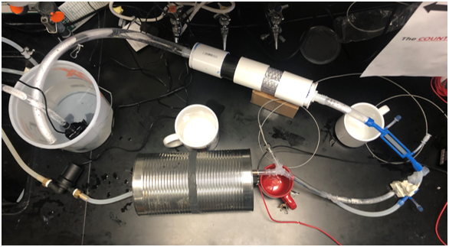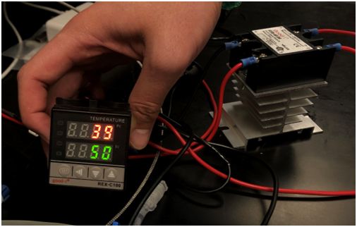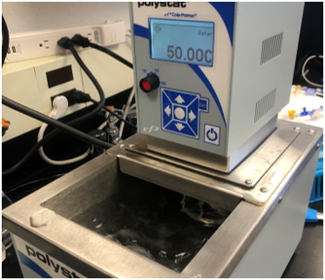
Figure 10: Heating Element Prototypes; Top Left: Tank w/ PID (Discontinued), Top Right: PID Controller (Discontinued), Bottom: ColeParmer Polystat 6.5L 200C (Current)

Design Iteration 4: Change in Connectors discussion
During the early testing process, the lab’s non-obstructing universal connectors were used as “quick disconnects” for varying model types. However, these connectors often had leaks due to the heat deflection induced by the heating element. The Stratasys spec sheet of Vero clear indicated that heat deflection would be present at 45 – 50 degrees Celsius [5]. Furthemore, an additional Y-connector would be needed to
After the 66% build demonstration, Professor Willy suggested using a manifold to reduce the number of stopcocks in our design. Instead of using a manifold for air bleeds, a manifold was implemented in the inlet/outlet ports to connect the vessel models to the system. The advantage to the manifold assembly was its ability to activate/deactivate the flow channels when not in use. The manifold assembly was designed to accommodate one CW model, but could accommodate three models with singular channels.
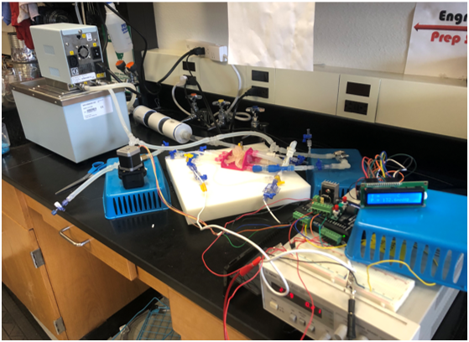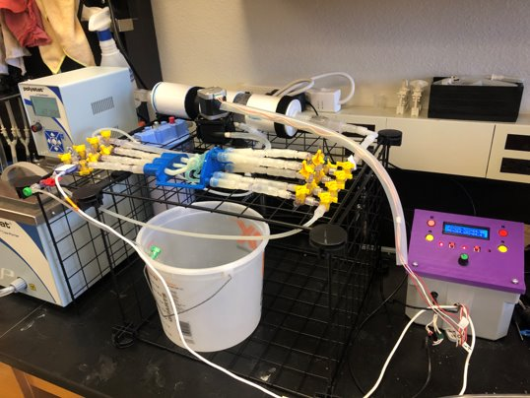
Figure 11: CVC Prototypes; Left: 66% Design, Right: Present Design

Challenges Bested
As discussed in Design Iteration 2 and 3, one challenge that was bested was finishing the heating tank replacement with the Polystat heat bath. Another challenge was compiling the electrical wiring onto the PCB boards. The process included switching all the wire that was used in the breadboard prototyping phase to 20 gauge, soldering the 20 gauge wire to PCB boards, and fitting all the connections into the electronics housing. This soldering process was a challenge because the wires would tend to detach if the electronics housing was moved or opened. The wiring of the electronics components was also challenging because the two electrical systems had to be connected and fit in the housing.

Testing

Testing Plan
The experimental details of the testing plan are described below. Table 2 shows what experiments will correlate to the ERs/CRs.

Experiment 1 – Filter Capacity
This experiment evaluates the mass of support material that can be contained before emptying the filter. Furthermore, if the flow path is completely obstructed by support material, the pressure will increase within the system. The average Circle of Willis model without Aneurysms has a support material mass of 11 grams. Therefore, a capacity of 110 grams can clean 10 Circle of Willis models before the filter needs to be cleaned. Recycled support material that has been pre-soaked in NaOH for at least 20 minutes will be added to the filter and the proximal pressure will be compared to pressure of a filter without support material. Preliminary testing has been completed to determine no increase in pressure after adding 87 grams of support material. Therefore, it is anticipated that the filter will be able to reach the target of 10 cleaning cycles before replacement.

Experiment 2 – Model Failure Pressure
Using a clean sidewall aneurysm model with an open manifold channel, the system will be subject to the maximum potential output pressure until failure. This model was selected because the aneurysm neck has a smaller wall thickness, making it more vulnerable to the fluid pressure. The cleaning cycle will be maintained at a temperature of 43 C and will progressively increase in pressure until failure. The pressure will start at 130 mmHg and will increase by 10 mmHg every 10 minutes. Prior to increasing pressure, a bucket-timer test will be performed to document the occurring flow rate. If maximum pressure on the peristaltic pump has been reached, a medical-grade gate valve will be introduced at the outlet where the diameter will increase, blocking flow, and increasing pressure as a result. This will be used to determine the pressure value needed to trigger the pressure notification alarms. Preliminary testing with clean model conditions has indicated that 135 mmHg of an open channel will rupture an aneurysm neck. In the scenario of an unclean model, pressures greater than 400 mmHg will rupture the vessel contents (this effect was caused by pressure buildup due to sealed manifold channels).

Experiment 3 – Model Deflection
In preliminary model tests, the vessel model inlets/outlets had observable bending. This was induced by the torque caused by unmanaged tubing and the temperature effects on the model framing. The manifold design has reduced the model deflection, but changes in tubing length for inlets and outlets may cause some mild deflection. Cleaning experiments at 49 C will be performed to determine if this behavior is still observed during the cleaning process. Results will be contrasted between inlet connector types (Exterior Barb vs. Interior Rib) to determine if they influence model deformation. If further deformation occurs, the maximum temperature will need to be decreased. This experiment will be performed with Experiments 4 and 5 to reduce 3D print costs and number of procedure times during the testing cycle.

Experiment 4 – Sodium Hydroxide Pretreatment TIme
Regardless of pressure and temperature supplied to the vessel models, Sodium Hydroxide (NaOH) is required for pretreatment to break up the support material. This experiment will analyze the minimum time needed to soak the interior section of a vessel in NaOH. The cleaning cycle will be maintained at the testing temperature currently being tested (See Experiment 3) and a maximum pressure determined by Experiment 2. Circle of Willis Models will be soaked at varying times of 6, 12, and 24 hours at an inverted angle to allow NaOH to break up support material.

Experiment 5 – Minimum Model Cleaning Time
While experiments 2,3, & 4 are being performed, the cleaning time and variables will be recorded to determine the most efficient conditions for model cleaning. Efficiency is determined by the amount of time it takes to clean the models without manual operation. The end goal of this project is to increase the Bioengineering Devices Lab productivity by reducing the time required to manually clean the models. Therefore, the least amount of model cleaning time will be most ideal when providing specification sheet values to the client. Preliminary testing has been completed to determine that the minimum model cleaning time is 4 hours (excluding NaOH Pretreatment time).

Table 2: Testing Plan
Experiment/Test | Description | Relevant DRs
Ex1 | Filter Capacity | CR8, ER5, CR9, ER13
Ex2 | Model Failure Pressure | ER10, CR16, ER3, CR1
Ex3 | Model Deflection | CR2, ER1, CR15, ER11
Ex4 | Minimum Sodium Hydroxide Pretreatment Time | CR17, ER9, CR5
Ex5 | Minimum Model Cleaning Time | CR1, CR2, CR5, CR17 ER1, ER3, ER9, ER17

Testing Results
After testing was completed specification sheets were compiled from the results. Below are the specification sheets which show if the ERs/CRs of the project were met. Table 3 also displays the targets and measured values for each ER. The CR and ER for fast cleaning time was not met, however the measured value for the ER was client acceptable. This was the only Engineering requirement that the measured value did not meet the target value within the tolerance.

Table 3: Specification Sheet Engineering Requirements
Engineering Requirement | Description | Target | Units | Tolerance | Measured Value | ER Met? | Client Acceptable?
ER1 | Maximum Water Temperature | 49 | °C | +150, - 5 | 49 | Yes | Yes
ER2 | Flow Rate | 4 | L/min | +/-2 | 3 | Yes | Yes
ER3 | Maximum System Pressure | 200 | mmHg | +/- 50 | 200 | Yes | Yes
ER4 | Reservoir Capacity | 1 | L | +/4 | 5 | Yes | Yes
ER5 | Support Material Filter Capacity | 100 | g | -20, +100 | 130 | Yes | Yes
ER6 | Heating Voltage | 12 | V | +/- 1 | 12 | Yes | Yes
ER7 | Peristaltic Pump (PP) Voltage | 24 | V | +/- 1 | 24 | Yes | Yes
ER8 | System Dimensions | 3x2x0.83 | feet | -/1 | 2.5x1.2x1.2 | Yes | Yes
ER9 | Cleaning Time | 2 | hours | +/0.5, -/2 | 4 | No | Yes
ER10 | Pressure Gauge Resolution | 1 | mmHg | +/- 0.5 | 1 | Yes | Yes
ER11 | Temperature Gauge Resolution | 1 | °C | +/- 0.5 | 0.01 | Yes | Yes
ER10 | Working System Pressure | 150 | mmHg | +/- 75 | 200 | Yes | Yes
ER12 | Filter Minimum Mesh Size | 1000 | microns | +/ 250 | 200 | Yes | Yes
ER13 | Signal Response Delay | 1 | seconds | +/- 0.5 | 1 | Yes | Yes
ER14 | Working Water Temperature | 37 | °C | +13, -17 | 43 | Yes | Yes
ER14 | Vessel Model Maximum Port Count | 3 | - | 0 | 3 | Yes | Yes
ER15 | Proximal - Distal Pressure Differential | 0 | mmHg | +/ 15 | 12 | Yes | Yes

Table 4: Specification Sheet Customer Requirements
Customer Requirement | Description | CR met? | Client Acceptable | Corresponding ER
CR1 | Water Pump | Y | Y | ER3
CR2 | Water Heater | Y | Y | ER1
CR3 | Heat On/Off | Y | Y | ER6
CR4 | System On/Off | Y | Y | ER7
CR5 | Fast Cleaning | N | Y | ER9
CR6 | Water Reservoir | Y | Y | ER4
CR7 | Mesh Filtration | Y | Y | ER13
CR8 | Multiple Cleaning Cycles before Filter Replacement | Y | Y | ER5
CR9 | Universal Connectors | Y | Y | ER16
CR10 | Adjustable Pressure | Y | Y | ER15
CR11 | Compact Design | Y | Y | ER8
CR12 | Pulsatile/Constant Flow Control | Y | Y | ER2
CR13 | Unruptured Models | Y | Y | ER15
CR14 | Temperature Measurement | Y | Y | ER11
CR15 | Pressure Measurement | Y | Y | ER10
CR16 | Clean Models | Y | Y | ER17

RISK ANALYSIS AND MITIGATION
In order to analyze the potential failures of our system, the team conducted a failure modes effect analysis (FMEA) which can be found in Appendix H. The purpose of the FMEA was to identify the cause, effect, and mechanism of each component failure. Each failure was given a score called the Risk Potential Number (RPN); the highest RPN valued failures are considered the highest risk failures. RPN is determined from three scores: severity, occurrence, and detectability. These scores undergo compound multiplication to calculate the final multiplication.
$RPN = Severity * Occurrence * Detectability$ (Eqn. 1)
Failures around a score of 30 are considered normal, while anything above should be tended too during the prototyping and testing phase. The goal of testing is to mitigate these high RPN failures. After testing the RPN for each function of the product should be low enough to consider the product complete. Failures were mitigated by making design decisions that were based on the benchmarking and literature that was used. One design decision that was made to mitigate a potential failure was to add a micron filter to the design which removes small support material particles from the water in order to reduce the potential for failure of the pump due to damage caused by support material. Another design decision was made to reduce the risk of failure due to aneurysm model deflection which would cause rupture in the model, the decision was to add a manifold that would align the model properly on the frame limiting any deflection.

Potential Failures Identified First Semester
An abridged FMEA from the first semester is included in Table 4. These failures are indicated by a RPN score of above 80. The highest scoring critical failure is caused by potential fluid blockages in the support material filter. This was given a high RPN because the severity, occurrence, and detectability of this failure were high. The recommended action to avoid this failure and lower the RPN score is to test the support material capacity in the filter that would result in a safe amount of fluid blockage and pressure build-up.

Potential Critical Failure 1: Mesh Filter Blockage
If the support material is not removed from the mesh filtration system, the SM will congregate, causing blockage of flow. This scored a RPN of 180 this can be lowered by testing ways to clear support material from the filter.

Potential Critical Failure 2: Pump Damage due to Support Material
This failure is caused by the mesh filter sustaining thermal fatigue which causes the mesh size to increase. The result of this is that support material will pass through the mesh filter and damage the pump. This could lead to the pump needing to be replaced. This can be avoided by testing and material selection.

Potential Critical Failure 3: Water surpasses max temperature
This failure is caused by the water heating element receiving too much voltage. The water would heat past the maximum temperature of the system and cause damage to the vessel model. This will be tested by seeing the voltage to temperature relation.

Potential Critical Failure 4: Excess Pump Flow
If the pump provides excess flow, the system will surpass the maximum pressure and damage the vessel model. This will be tested by pump sizing.

Potential Critical Failure 5: Short-Circuited Heating Element
This failure is caused by water spillage on the electronic controls of the water heater. The effects of this failure is that the heating system will stop working. This failure can be mitigated with proper assembly of all components ensuring there are no leaks. Furthermore, all exposed wires should be displaced from any sources of potential leakage.

Potential Critical Failure 6: Short-Circuited Pump
This failure is caused by water intersecting the electronic controls of the water pump, which can disrupt the pressure output. This failure can be mitigated with proper assembly of all components ensuring there are no leaks. Furthermore, all exposed wires should be displaced from any sources of potential leakage.

Potential Critical Failure 7: Overheated Pump
This failure will be caused by leaving the pump on for longer then . This will cause the pump to need to be replaced. This can be mitigated by selecting a pump with a long life and by having a proper shut off procedure.

Potential Critical Failure 8: Thermal Fatigue on Pump
This failure is caused by the pump undergoing thermal fatigue. The effects of this failure is there will be improper flow in the system or the pump needs to be replaced. This can be mitigated by selecting a pump that has the proper temperature specifications.

Potential Critical Failure 9: Air-Induced Pump Damage
This failure is caused because the pump is turned on while not fully submerged in water or from air getting into the system. The effects of this failure is pump damage and could lead to premature pump replacement. To reduce the risk of this failure, the pump should never be turned on while not in the system and all connections must be airtight.

Potential Critical Failure 10: Heating Element Damage
This failure would be caused by over using the water heater. Consequences of this failure include part replacement or insufficient temperatures. The way to mitigate this failure is to choose and test a water heating element that has the proper specifications.

Table 4: First Semester Shortened FMEA
Part # and Functions | Potential Failure Mode | Potential Effect(s) of Failure | Potential Causes and Mechanisms of Failure | RPN | Recommended Action
1- heats water | Thermal Fatigue | heating system fail, part replacement | over voltage | 96 | Testing
1-heats water | Corrosive Wear | Improper water temp. | build up from water not cleaned off | 60 | Add a water filter.
1-heats water | high cycle fatigue | heating system fail, part replacement | left on too long, over voltage | 72 | Testing
1-heats water | Thermal Fatigue | heating system fail, part replacement | Left on while tank has no water | 72 | Proper shut down procedure
2-Holds hot water | Thermal Fatigue | Leaking, Tank needs replacement, Potential system failure | Not proper material to withstand temperature | 16 | Material selection
2-Holds hot water | Fatigue from use | Leaking, Tank needs replacement, Potential system failure | improper construction | 15 | testing
2-Holds hot water | Evacuated tank | heating element sustains damage, tank sustains gammage | improper size | 36 | testing
3-Reads temperature outside tank | No power | no temperature reading | turn on procedure not followed, improper set up | 10 | proper set up and turn on procedure
2-Holds hot water | sizing | restricts flow of system | improper sizing or connection | 12 | testing all components together
1-heats water | fracture | no hot water | improper assembly | 7 | proper assembly
5-pressure reading | Forein substance damage | no pressure reading, part replacement | water damages sphygmomanometer | 42 | Proper assembly, good care
6-moves water through system | Forein substance damage | no water movement, pump breaks, total failure | air gets into the system | 108 | Testing, proper assembly
6-moves water through system | over voltage | surpass max pressure, damage vessel model | flow is not controlled properly, pump gets too much power | 80 | testing, pump sizing
6-moves water through system | thermal fatigue | pump stops working | pump not suitable for hot water | 90 | testing with pump and hot water
6-moves water through system | high cycle fatigue | pump stops working | pump overworked, left on for too long | 36 | testing, pump specs
6-moves water through system | over heating | pump slows down the flow, not correct pressure | pump not meant to be kept on too long, gets too much power | 96 | testing , pump specs
6-moves water through system | under performance | vessel will not be cleaned, product failure, under desired pressure | pump not properly sized | 36 | testing, pump sizing
6-moves water through system | Air damage | pump breaks | not fully submerged in water, turned on while in air, pumping air not water, empty system | 9 | proper turn on conditions
6-moves water through system | Improper procedure | makes a mess of water | not turned off properly | 7 | proper turn off procedure
6-moves water through system | assembly | makes a mess of water, electrical hazard | not assembled properly, system is leaking anywhere | 18 | proper assembly
7-removes support material from fluid | thermal fatigue | mesh size increases, pump gets damaged by support material | hot water increases the mesh size and material is able to pass through | 135 | material properties, testing,
7-removes support material from fluid | corrosive wear | mesh size increases, pump gets damaged by support material | water corrodes the material making mesh size bigger | 54 | material properties, testing,
7-removes support material from fluid | fracture | support material getstrough the fracture, pump damage | improper assembly, bad care | 18 | proper assembly and good care of component
7-removes support material from fluid | SM Blockage | fluid blockages | support material build up on the filter | 180 | testing
7-removes support material from fluid | sizing | sup. Mat. Gets pushed through | pressure too high, mesh wrong size | 72 | testing
8-collects sup. Mat. Waste | SM Blockage | fluid back up | waste not emptied often enough, collection system too small | 28 | Testing
9-Removes impurities from water | corrosive wear | water heater acquires build up. | water filter is worn down and not filtering properly | 32 | Often maintenance
9-Removes impurities from water | high cycle fatigue | water heater acquires build up. | filter needs replacement | 8 | Filter specs
9-Removes impurities from water | thermal fatigue | water heater acquires build up. | filter gets damaged by hot water | 8 | Filter specs
9-Removes impurities from water | SM Blockage | fluid blockages | improper assembly, doesn’t filter fast enough | 48 | Testing
1-heats water | over voltage | heats water past max temp | too much power | 135 | Testing voltage to temp
6-moves water through system | over voltage | too much flow in system surpasses max pressure | too much power | 135 | testing pump
10-Controls electronics | short circuits | no control of data | water gets on arduino | 56 | Keep away from water, avoid leaks
3-Reads temperature | short circuits | no temperature reading | water gets on thermocouple | 48 | Keep away from water, avoid leaks
6-moves water through system | short circuits | no flow | water gets on electrical components of pump | 80 | proper assembly
10-Controls electronics | unsupervised | system left on, damage to all components | not turned off properly | 8 | proper shut off procedure
10-Controls electronics | electrical connections | product will not work | Arduino not connected properly | 54 | proper assembly
All components | short circuits | product will not work | product requires too much power | 36 | testing all components together
1-heats water | short circuits | component will not work | water gets on electrical components of heater | 135 | proper assembly
All components | wires disconnect | product will not work | components not connected correctly | 54 | proper assembly

Potential Failures Identified This Semester
All modes of failure are listed in Appendix H2, with exception to modes regarding the initial filter composed of parts F1-5, are new modes discovered during ME 486C. This is due to a change in the primary heating and pumping system, a change in the system layout, design and manufacture of electronic components, and testing conducted. Because the initial filter has not changed, all failure modes previously addressed have been unchanged throughout the semester. Before each component was added to the system, operational testing was conducted to ensure safety and discover any potential modes of failure during operation of the device as a whole. After incorporation, testing for efficiency methods were conducted resulting in understanding of additional, unforeseen, failures. The single mode of failure that helped define the most important warnings during system use was the fracture of Stopcocks in the system. In-house Stopcocks were used to develop the system, and through testing the team discovered they are made primarily of poly-carbonate (PC). Upon further research, 50-80% NaOH concentration produces a severe effect when introduced to PC [6]. While the system can handle greater amounts of NaOH, if the system is cleaned more regularly, all Stopcocks should be replaced with ones only made from High Density Poly-Ethylene (HDPE) to improve efficiency resulting in faster cleaning times.
The highest scoring failure (120) is corrosive wear in part E1 the Polystat Heat Bath. This will occur due to improper use of fluid as there is build up inside the water reservoir of the bath. The recommended action if this occurs is to make sure the water is properly filtered as it enters the device, and replacing the water in the system. The second highest scoring failure is thermal fatigue, lack of power, or over heating in part C2 the Peristaltic Pump (108). This failure can cause a water leak, no pulsatile movement or no water movement; and can be caused by inlet or outlet tubing disconnecting, being powered for too long (6-8 hours in one cleaning cycle) or faulty wiring. To prevent or fix this failure, wiring and the connection of inlet/outlet tubing should be checked often, the heat sink should be tested, or the periods of cleaning models should be reduced. The final critical failure (96), is from fracture in a Medical Stopcock (part G1). Fracturing is most likely to be caused by a build of NaOH in the system and will create a fluid leak. To prevent this, NaOH should not be introduced into the system directly and the system's fluid should be changed on a regular schedule to prevent an increase in basicity. In the event of a fracture, the working fluid should be rerouted away from the broken Stopcock and/or the system should be shut down immediately. The fractured part can then be inspected and replaced.

Risk Mitigation
During the manufacturing process of each subsystem, specific testing was implemented to analyze potential modes of failure. As additional failures arose, testing and analysis was conducted to determine the likelihood of failure during long-term operation. To help prevent all short circuit modes of failure in electronics held in the Junction Box, cable glands and a plastic tarp were purchased and added to the design to prevent water entering the box via the wires and openings in the faceplate for operation. However, due to the size of the box and the cable glands, the Arduino’s serial connector had to be stripped and re-soldered to fit within the box. Furthermore, a micron-scale filter was implemented to remove smaller support material particles from the water in order to reduce the potential for failure of the pump.

Dr. Becker will be provided with an operations manual including all modes of failure and warnings with additional information regarding courses of action when using the system. This will include a recommended period in which system cleaning should occur. This reduces and/or prevents any corrosive wear to the Polystat Heat Bath and fracture to system Stopcocks. Information regarding suggested replacements for system Stopcocks in the event cleaning times need to be decreased, and a procedure to check the wiring of all subsystems to prevent lack of power issues. This manual will also include a procedure for starting the system, including checking all tube connections and ensuring the proper Stopcocks are opened to not create a pressure build up that could disconnect a tube from its barb connector. General information regarding the maximum tested debris added to the system without pressure change, and recommended maximum run time will be provided; however, it is unlikely the system will be operated beyond those suggested limits. This is due to the tested filter capacity being greater than the amount of support material cleaned from models on a two to three month basis. However, this duration could be longer or shorter depending on the lab’s research needs.

LOOKING FORWARD

Future Testing Procedures
Mechanical testing of support material properties would help determine the exact system settings needed to clean SM in the least amount of time possible. This can be determined by using the BDL’s Rheometer and using compression tests for varying levels of temperature and soak time. Design choices made for the system were developed based on previous specifications used to clean models developed by the Mentor.

While some preliminary results were produced by the testing of the system, the BDL will need to experiment with the system to produce the best results. Such experimentation includes output temperature, output pressure, and NaOH exposure. Since the lab is experimenting with a variety of model types (i.e. Sidewall, Balloon Stent Prototype, CW, and DAR), the lab will have newer cleaning procedures for each new vessel model they produce.

Future Iterations
Currently, the system can clean “Light” and “Standard” support material configurations. However, the “Heavy” support material cannot be cleaned without causing blockage in the current system. To change this, new manifolds and connectors with an ID of at least 5-6 mm would need to be created to prevent said blockage.

To implement a NaOH based fluid supply within the system, some device revisions would need to be made. The current heating element within the system cannot handle drastic changes in pH. This would be accomplished by using machinery that would not have contact with the NaOH, such as a heating plate and a peristaltic pump to remove the fluid from the reservoir. Since the peristaltic pump’s motor applies compression and expansion on the tubes, it is not at risk for chemical degradation. Additionally, the current manifold assembly is made of PC, which has fractured upon introduction of NaOH. PC can also be found as the base material for the systems PTs, so a different pressure transducer/pressure collection method would be needed to measure pressure in the system.

Finally, a self-regulating pump would eliminate the need for user-adjustment, improving productivity within the lab. This system would adjust the pressure output if values were too high or shut-off completely if values were too low. This could be programmed on an arduino, but it may require additional circuit prototyping, as it would effectively replace some of the driver/controller components.

CONCLUSIONS
After measuring the testing results it was determined that the product design was capable of completely satisfying all design requirements to a point that the client deemed acceptable. This means that the goal of the project was accomplished. The product can clean aneurysm models in an acceptable amount of time, the system can reach the max water temperature and pressure targets, and the design is compact. The product also has room for improvements such as the arduino code being modular and the overall tubing and manifolds having the capabilities to be replaced in order to implement NaOH based cleaning methods. The team also reached their goal that was stated at the beginning of Spring 2022 which was to successfully complete the project.

Reflection
The goal of this project was to provide a method of in-vitro model pre-treatment for further stroke device research. Considering the high mortality rate of strokes [2,3], the in-vitro models will be useful for future reduction of this mortality rate. Therefore, this system can be used as a stepping stone for further stroke prevention research at the BDL.
The most prominent risks of designing this system was electrical shock and scalding. Considering the amount of water spillage potential, we had to minimize the number of exposed wires and ensure that any propagated leaks could be contained. Furthermore, second- and third-degree burns had been a concern after a team member had been exposed to the water after changing tubing during the process.

Resource Wishlist
Had the team entered the lab sooner during 476C, they could have performed more prototyping and resolved some of the design issues they had encountered sooner. Had the team been provided old or unused equipment from the lab sooner, they could have used it as a baseline for their model-cleaning process. Furthermore, since Steven works at the BDL, he was able to enter the lab frequently with the rest of the team. However, for future projects composed of groups that do not work at the lab, they will need key access if using lab materials for their design.

Project Applicability
Overall, the project helped the team formulate testing procedures and practice their project management ability. The team made a few failures in the design process, but each failure gave the team a unique learning experience.

REFERENCES

[1] “Bioengineering Devices Lab,” Mechanical Engineering. [Online]. Available: https://nau.edu/mechanical-engineering/bioengineering-devices-laboratory/. [Accessed: 08-Apr-2022].

[2] “Statistics and Facts,” Brain Aneurysm Foundation, 05-May-2021. [Online]. Available: https://www.bafound.org/about-brain-aneurysms/brain-aneurysm-basics/brain-aneurysm-statistics-and-fac ts/#:~:text=There%20are%20almost%20500%2C000%20deaths,one%20year%20were%20%24150%20m illion. [Accessed: 04-Mar-2022].
[3] “The top 10 causes of death,” World Health Organization. [Online]. Available: https://www.who.int/news-room/fact-sheets/detail/the-top-10-causes-of-death#:~:text=Stroke%20and%20chronic%20obstructive%20pulmonary,4th%20leading%20cause%20of%20death. [Accessed: 05-Dec-2022].
[4]“3D CAD Models | Qosina,” www.qosina.com. https://www.qosina.com/3d-cad-models-2 [accessed Dec. 05, 2022].

[5] “Vero: A realistic multi-color 3D printing material,” Stratasys. [Online]. Available: https://www.stratasys.com/en/materials/materials-catalog/polyjet-materials/vero/. [Accessed: 04-Dec-2022].

[6] “Polycarbonate Chemical Compatibility Chart,” CP Lab Safety. [Online]. Available: https://www.calpaclab.com/polycarbonate-chemical-compatibility-chart/. [Accessed: 04-Dec-2022].

APPENDICES

Appendix A: Functional Decomposition Model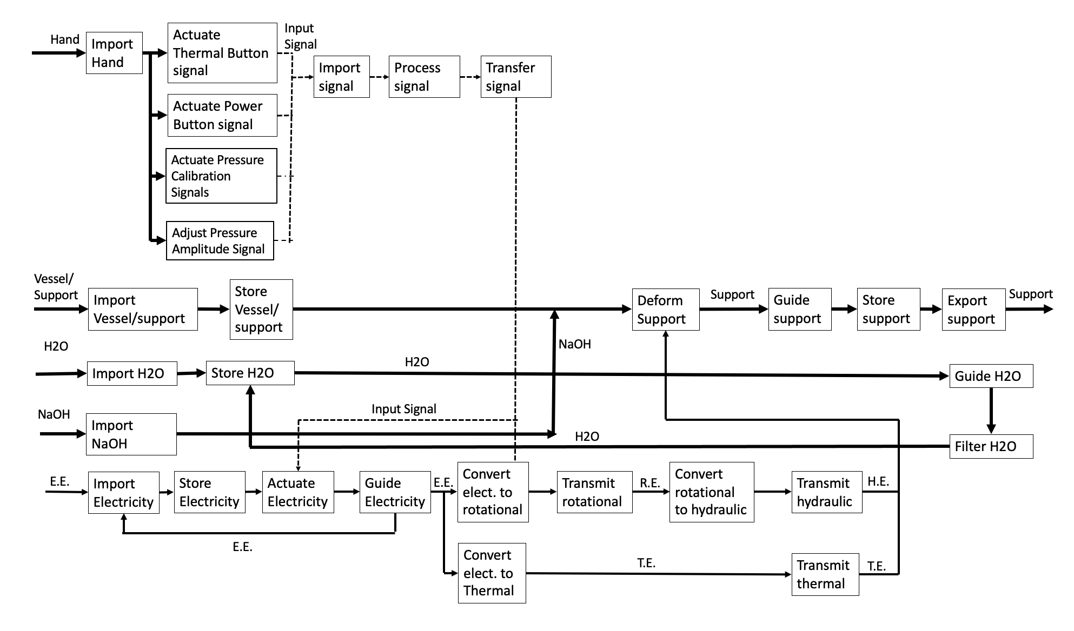

Appendix B: House of Quality
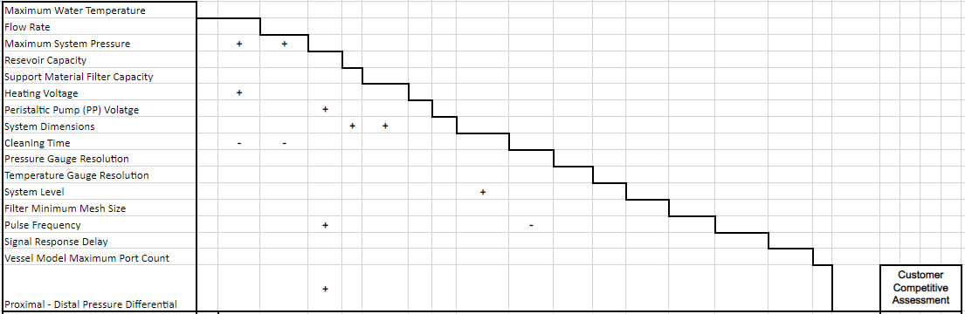
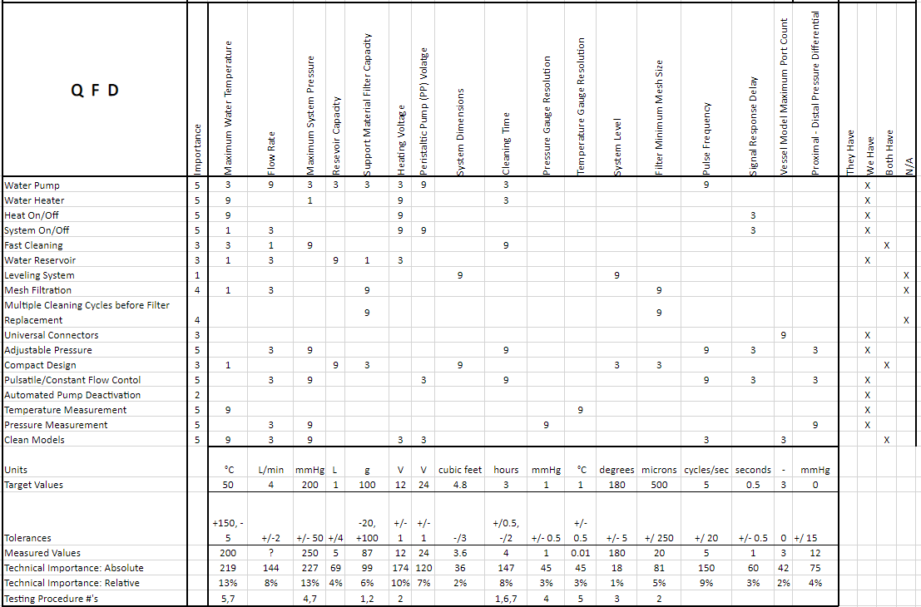
Figure B. QFD

Appendix C: Engineering Analysis - Head Loss

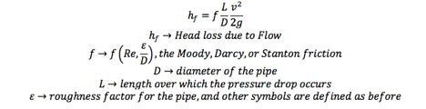

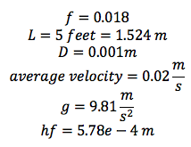

Appendix D: Gantt Chart
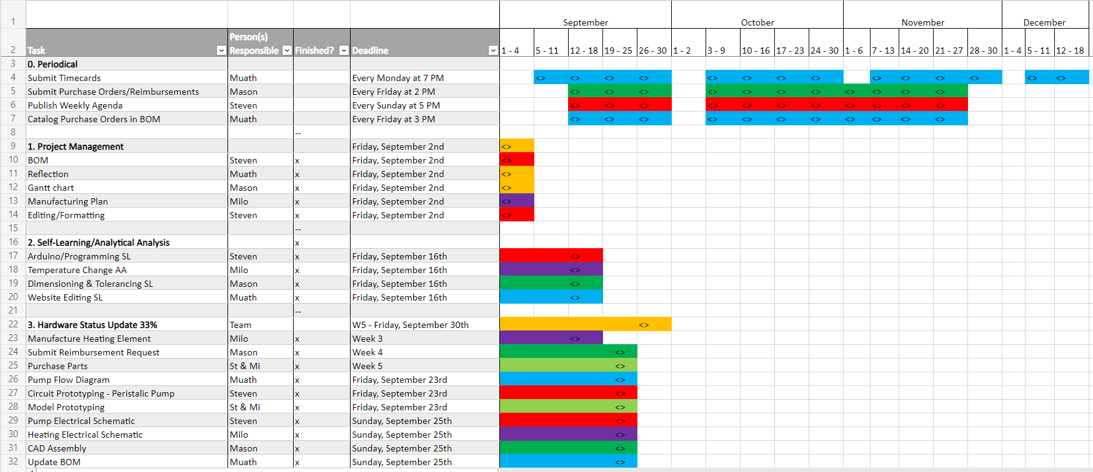
Table C. Gantt Chart

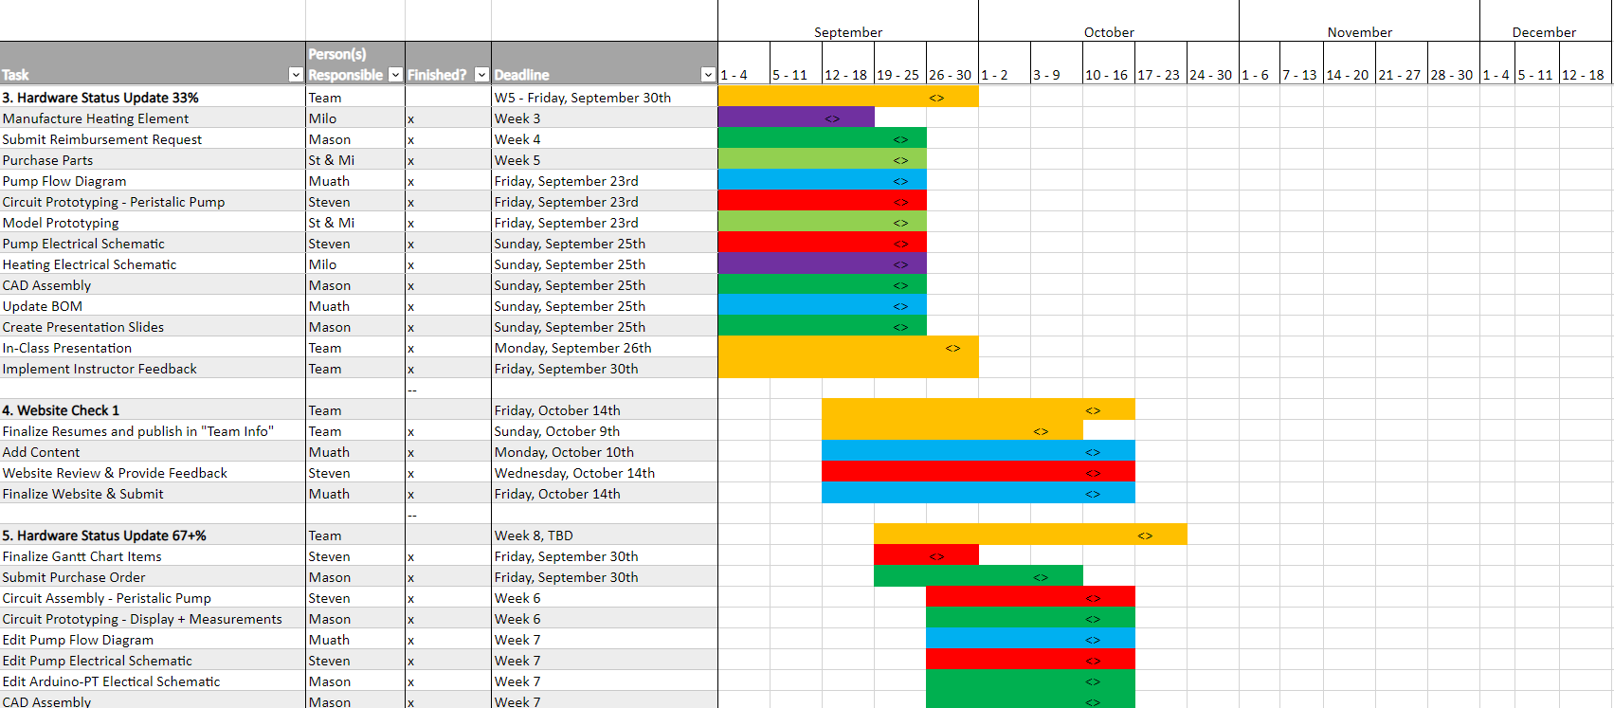

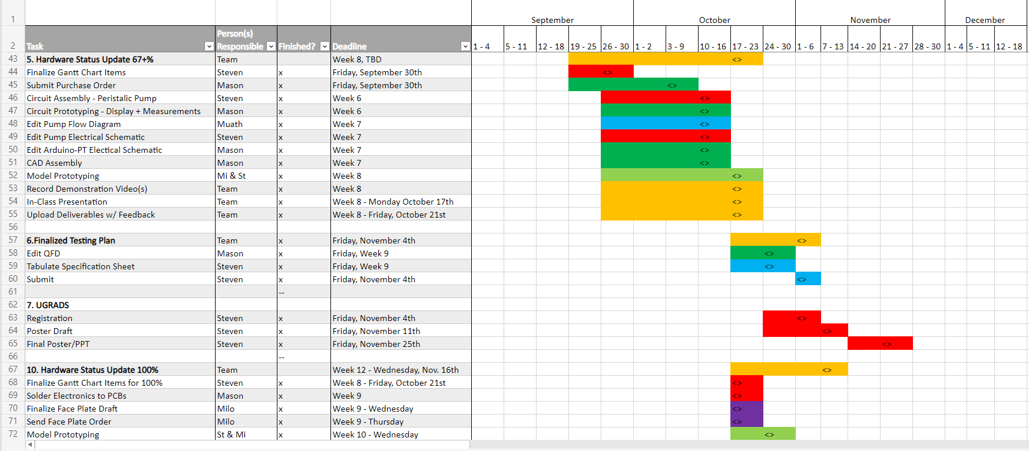

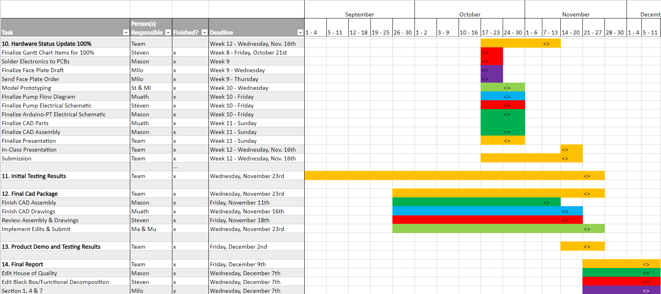

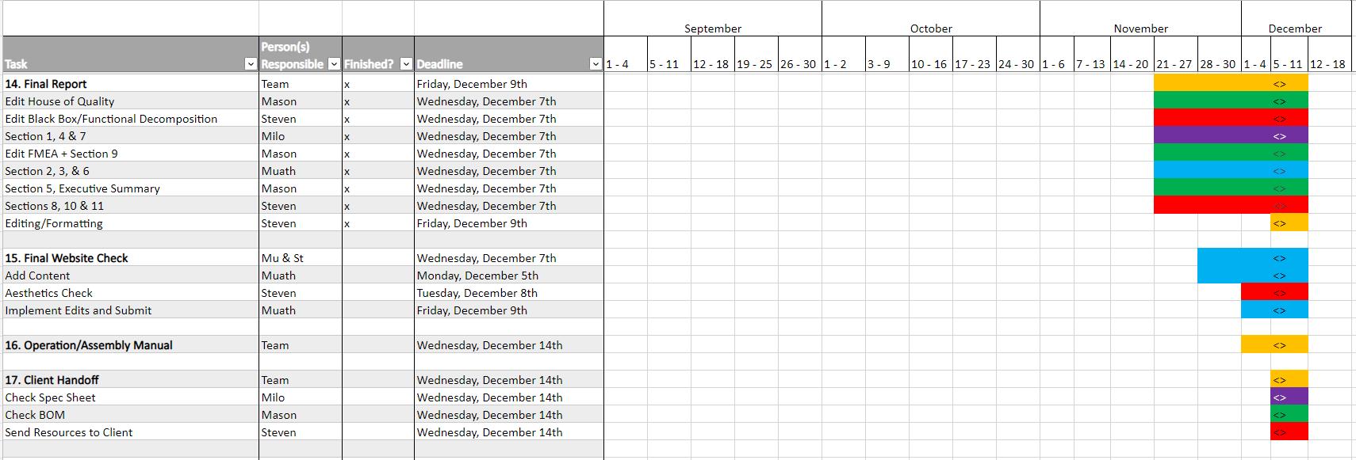

Appendix E: Bill of Materials
Table D1. BOM Full
Part # | Description | Qty | Units | Unit Cost | Total Cost | Part Status
A1 | SunFounder MEGA | 1 | NA | $19.99 | $19.99 |  | In House
A2 | PCB Board | 2 | NA | $6.39 | $12.78 |  | Purchased
A3 | Faceplate Breadboard | 1 | NA | $1.00 | $1.00 |  | In House
A4 | LCD Monitor | 1 | NA | $4.50 | $4.50 |  | In House
A5 | Disposable Pressure Transducer | 2 | NA | $20.00 | $40.00 |  | In House
A6 | 20 Gauge Wire | 72 | in. | $0.02 | $1.22 |  | Purchased
A7 | 4 Port Screw Terminal Connector Block | 2 | NA | $1.00 | $2.00 |  | In House
A8 | SPDT Button | 4 | NA | $0.28 | $1.12 |  | In House
A9 | HX711 Analog to Digital Converter | 2 | NA | $2.16 | $4.32 |  | In House
A10 | Solder Wire | 3 | g | $0.12 | $0.35 |  | In House
A11 | Arduino Active Buzzer | 1 | NA | $0.53 | $0.53 |  | In House
A12 | High Calibration LED Indicator (Blue Bulb) | 2 | NA | $0.03 | $0.06 |  | In House
A15 | 100k Resistor | 4 | NA | $0.59 | $2.36 |  | In House
A16 | 10k Potentiometer | 1 | NA | $0.80 | $0.80 |  | In House
A17 | 10K Resistor | 4 | NA | $0.60 | $2.40 |  | In House
A18 | Male to Screw Teminal Connector | 1 | NA | $0.62 | $0.62 |  | In House
B2 | MG Silicone Tubing 1/4" ID, 3/8" OD | 3 | ft | $1.00 | $3.00 |  | In House
B3 | Everbilt Vinyl Tubing 5/8" ID, 7/8" OD | 0.167 | ft | $1.51 | $0.25 |  | In House
B4 | UDP Vinyl Tubing 3/4" ID, 1" OD | 0.208 | ft | $2.96 | $0.62 |  | In House
C2 | Peristaltic Pump | 1 | NA | $39.90 | $39.90 |  | In House
C3 | Peristaltic Pump Controller | 1 | NA | $28.99 | $28.99 |  | In House
C4 | Peristaltic Pump Driver | 1 | NA | $13.99 | $13.99 |  | In House
C5 | Peristaltic Pump Heat Sink | 1 | NA | $8.99 | $8.99 |  | In House
D1 | Device Framing | 1 | NA | $28.00 | $28.00 |  | Manufactured
D2 | Electronics Faceplate | 218 | g | $0.12 | $26.16 |  | Manufactured
D3 | Electronics Framing | 195 | g | $0.12 | $23.40 |  | Manufactured
D4 | Electronics Housing (Junction Box) | 1 | NA | $18.95 | $18.95 |  | Purchased
D5 | Cable Gland (.100-.360" Cord Range For 1/2" KO) | 1 | NA | $2.78 | $2.78 |  | Purchased
D6 | Cable Gland (.200-.472" Cord Range For 1/2" KO) | 1 | NA | $2.98 | $2.98 |  | Purchased
D7 | Zip Ties | 4 | NA | $0.01 | $0.04 |  | In House
D8 | Velcro Straps | 30 | in. | $0.07 | $2.18 |  | Purchased
E1 | Cole-Parmer Polystat Standard Heated Bath | 1 | NA | $2,172.00 | $2,172.00 |  | In House
F1 | Filter Mesh (deconstructed aquarium net) | 1 | NA | $3.49 | $3.49 |  | Manufactured
F2 | 2 in. PVC Schedule 40 S x S Coupling | 3 | NA | $2.11 | $6.33 |  | Manufactured
F3 | 2 in. x 2 ft. ABS (DWV) Pipe | 0.25 | ft | $4.49 | $1.12 |  | Manufactured
F4 | 2 in. I.D. x 2 ft. PVC Braided Vinyl Tube | 0.25 | ft | $5.42 | $1.36 |  | Manufactured
F5 | 2 in. x 1 in. PVC Reducer Bushing | 2 | NA | $3.12 | $6.24 |  | In House
F6 | Pentair 150071 Filter Housing | 1 | NA | $47.41 | $47.41 |  | In House
F7 | GE G Filter | 1 | NA | $4.74 | $4.74 |  | In House
G1 | Medical Stopcock | 20 | NA | $1.00 | $20.00 |  | In House
G2 | 3/8" x 3/8" Barb Elbow | 4 | NA | $0.88 | $3.52 |  | Purchased
G3 | 3/8" x 3/8" x 3/8" Barb T Connector | 1 | NA | $0.72 | $0.72 |  | Purchased
H1 | Power Center | 1 | NA | $25.00 | $25.00 |  | In House
H2 | USB Data Sync Connector | 1 | NA | $10.00 | $10.00 |  | In House
I1 | 5 QT Fluid Reservoir | 1 | NA | $4.48 | $4.48 |  | In House
H3 | 24V Power Supply | 1 | NA | $17.45 | $17.45 |  | In House
Total Number Parts |  | 563.375 | Total Cost |  | $2,618.14

Table D2. BOM - Purchasing Plan
Part # | Description | Qty | Unit Cost | Total Cost | Part Status | Where? | Cycle?
NA | 4 Channel 12V Relay | 1 | $7.99 | 7.99 | Purchased | Amazon
R1 | Yellow Spade Terminal | 2 | $0.38 | 0.76 | Purchased | HomeCo | 33%
NA | Blue Spade Terminal | 10 | $0.15 | 1.50 | Purchased | HomeCo | 33%
C2 | Peristaltic Pump | 2 | $39.90 | 79.8 | Purchased | Amazon | 33%, 66%
C3 | Peristaltic Pump Controller | 2 | $28.99 | 57.98 | Purchased | Amazon | 33%, 66%
C4 | Peristaltic Pump Driver | 2 | $13.99 | 27.98 | Purchased | Amazon | 33%, 66%
NA | Circulation Pump | 1 | $19.90 | 19.90 | Purchased | Amazon | 33%
NA | 40A Steady State Relay | 2 | $5.00 | 10 | Purchased | Amazon | 33%
NA | Waterproof K-type Thermocouple | 1 | $10.00 | 10.00 | Purchased | Amazon | 33%
H1 | Power Center | 1 | $25.00 | 25.00 | Purchased | Home Depot | 33%
A2 | PCB Board | 5 | 2.56 | 12.78 | Purchased | Amazon | 66%
B2 | Medical Grade Silicone Tubing | 3 | 1.00 | 3.00 | Purchased | Amazon | 66%
H3 | 24V Power Supply | 1 | 17.45 | 17.45 | Purchased | Amazon | 66%
A6 | 20 Gauge Wire | 72 | $0.02 | $1.22 | Purchased | NA | 100%
D1 | Device Framing (14” x 14” x 14” Wire Shelves) | 1.2 | $7.00 | $8.40 | Purchased | Amazon | 100%
D4 | Electronics Housing (Junction Box) | 1 | $18.95 | $18.95 | Purchased | Home Depot | 100%
D6 | Velcro Straps | 30 | $0.07 | $2.18 | Purchased | Home Depot | 100%
G2 | 3/8" x 3/8" Barb Elbow | 4 | $0.88 | $3.52 | Purchased | NA | 100%
G3 | 3/8" x 3/8" x 3/8" Barb T Connector | 1 | $0.72 | $0.72 | Purchased | NA | 100%
A8 | Push Button | 70 | 0.28 |  | Purchased | Amazon | Testing
R2 | Plastic Drop Down | 1 | 4.87 | 4.87 | Purchased | Home Depot | Testing

Table D3. BOM - Manufacturing Plan
Part # | Description | Qty | Unit | Unit Cost | Total Cost | Part Status | Where? | When?
F1 | Filter Mesh (deconstructed aquarium net) | 1 | NA | $3.49 | $3.49 | Manufactured | Cut & PVC cemented into coupler @ Home | 476C
F2 | 2 in. PVC Schedule 40 S x S Coupling | 3 | NA | $2.11 | $6.33 | Manufactured | PVC cemented to tubing/pipe & reducer @ Home | 476C
F3 | 2 in. x 2 ft. ABS (DWV) Pipe | .25 | ft | $4.49 | $1.12 | Manufactured | Cut & PVC cemented into coupler @ Home | 476C
F4 | 2 in. I.D. x 2 ft. Braided Vinyl Tubing | .25 | ft | $5.42 | $1.36 | Manufactured | Cut & PVC cemented into coupler @ Home | 476C
F5 | 2 in. x 1 in. PVC Reducer Bushing | 2 | NA | $3.12 | $6.24 | In House | PVC cemented to coupler @ Home | 476C
B3 | MG Silicone Tubing 1/4" ID, 3/8" OD | 3 | ft | $1.00 | $3.00 | Manufactured | Cut @ BDL | 100%
D1 | Device Framing (14” x 14” x 14” Wire Shelves) | 1.2 | NA | $7.00 | $8.40 | Manufactured | Cut w/ Dremel @ BDL | 100%
D2 | Electronics FacePlate | 218 | g | $0.12 | $26.16 | Manufactured | 3D Printed @ Cline Library | 100%
D3 | Electronics Framing | 195 | g | $0.12 | $23.40 | Manufactured | 3D Printed @ Cline Library | 100%
D4 | Electronics Housing (Junction Box) | 1 | NA | $18.95 | $18.95 | Purchased | Holes cut with hole saw @ BDL | 100%
D5 | Cable Gland | 1 | NA | $2.78 | $2.78 | Purchased | Attached @ BDL | 100%
D6 | Cable Gland | 1 | NA | $2.98 | $2.98 | Purchased | Attached @ BDL | 100%
NA | DAR Model Prints | 180 | g | $0.50 | $90 | Manufactured | Printed @ the BDL | Testing

Appendix F: Arduino Electrical Schematic

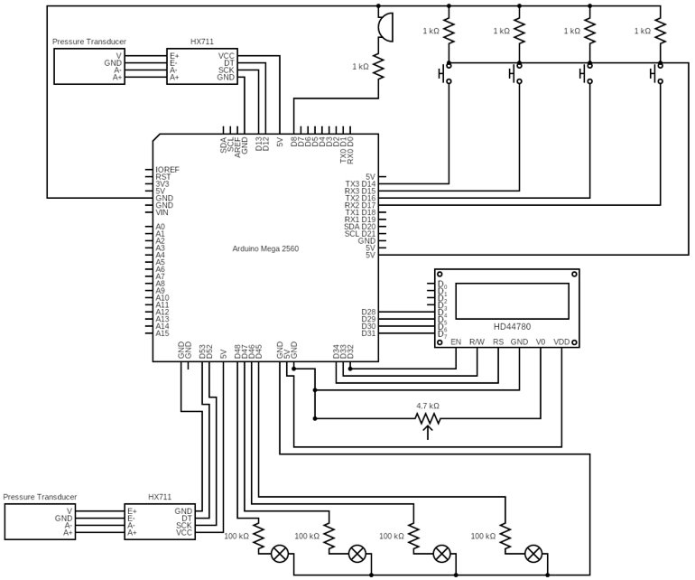
Figure F1:____

Appendix G: Specification Sheets
Table G1: CR Specification Sheet
Customer Requirement | Description | CR met? | Client Acceptable | Corresponding ER
CR1 | Water Pump | Y | Y | ER3
CR2 | Water Heater | Y | Y | ER1
CR3 | Heat On/Off | Y | Y | ER6
CR4 | System On/Off | Y | Y | ER7
CR5 | Fast Cleaning | N | Y | ER9
CR6 | Water Reservoir | Y | Y | ER4
CR7 | Mesh Filtration | Y | Y | ER13
CR8 | Multiple Cleaning Cycles before Filter Replacement | Y | Y | ER5
CR9 | Universal Connectors | Y | Y | ER16
CR10 | Adjustable Pressure | Y | Y | ER14
CR11 | Compact Design | Y | Y | ER8
CR12 | Pulsatile/Constant Flow Control | Y | Y | ER2
CR13 | Automated Pressure Regulation/  Pressure Alert System | Y | Y | ER15
CR14 | Temperature Measurement | Y | Y | ER11
CR15 | Pressure Measurement | Y | Y | ER10
CR16 | Clean Models | Y | Y | ER16
CR17 | Unruptured Models | Y | Y | ER17
CR18 | Undeformed Models | Y | Y | ER18

Table G2: ER Specification Sheet

ER# | Description | Target | Units | Tolerance | Measured Value | ER Met? | Client Acceptable? | CR#
ER1 | Working Water Temperature | 37 | °C | +13, -17 | 43 | Yes | Yes | CR2
ER2 | Flow Rate | 4 | L/min | +/-2 | 3 | Yes | Yes | CR12
ER3 | Working System Pressure | 150 | mmHg | +/- 75 | 200 | Yes | Yes | CR1
ER4 | Reservoir Capacity | 1 | L | +/5 | 5 | Yes | Yes | CR6
ER5 | Support Material Filter Capacity | 100 | g | -20, +100 | 130 | Yes | Yes | CR8
ER6 | Heating Voltage | 115 | V (AC) | +/- 1 | 115 | Yes | Yes | CR3
ER7 | Peristaltic Pump (PP) Voltage | 24 | V (DC) | +/- 1 | 24 | Yes | Yes | CR4
ER8 | System Dimensions | 3x2x0.83 | feet | -/1 | 2.5x1.2x1.2 | Yes | Yes | CR11
ER9 | Cleaning Time | 2 | hours | +/0.5, -/2.5 | 4 | No | Yes | CR5
ER10 | Pressure Gauge Resolution | 1 | mmHg | +/- 0.5 | 1 | Yes | Yes | CR16
ER11 | Temperature Gauge Resolution | 1 | C | +/- 0.5 | 0.01 | Yes | Yes | CR15
ER12 | Filter Minimum Mesh Size | 1000 | microns | -/ 900 | 200 | Yes | Yes | CR8
ER13 | Pulse Frequency | 5 | cycles/sec | +/ 20 | ? | Yes | Yes | CR11
ER14 | Signal Response Time | 1 | seconds | +/- 0.5 | 1 | Yes | Yes | CR14
ER15 | Vessel Model Inlet Count | 3 | No units | 0 | 3 | Yes | Yes | CR10
ER16 | Proximal - Distal Pressure Differential | 0 | mmHg | +/ 15 | 12 | Yes | Yes | CR16
ER17 | Maximum Water Pressure | 200 | mmHg | +200 | 400 | Yes | Yes | CR17
ER18 | Maximum Water Temperature | 49 | C | +50 | 49 | Yes | Yes | CR18

Appendix H: Failure Modes Effect Analyses
Table H1. Spring 2022 FMEA

Product Name | BDL CVC | Development Team | Spring 2022 BDL CVC capstone |  |  | Page No 1 of 1
System Name |  |  |  |  |  | FMEA Number 2
Subsystem Name |  |  |  |  |  | Date 04/08/2022
Component Name |  |  |  |  |  | Revised
Part # and Functions | Potential Failure Mode | Potential Effect(s) of Failure | Severity (S) | Potential Causes and Mechanisms of Failure | Occurrence (O) | Current Design Controls Test | Detection (D) | RPN | Recommended Action
1-heats water | high cycle fatigue | heating system fail, part replacement | 8 | left on too long, over voltage | 3 | Temperature Reading | 3 | 72 | Testing
2-Holds hot water | Thermal Fatigue | Leaking, Tank needs replacement, Potential system failure | 8 | Not proper material to withstand temperature | 1 | Visual | 2 | 16 | Material selection
2-Holds hot water | Fatigue from use | Leaking, Tank needs replacement, Potential system failure | 5 | improper construction | 3 | visual | 1 | 15 | testing
2-Holds hot water | Evacuated tank | heating element sustains damage, tank sustains gammage | 6 | improper size | 3 | Visual | 2 | 36 | testing
3-Reads temperature outside tank | No power | no temperature reading | 5 | turn on procedure not followed, improper set up | 2 | Visual | 1 | 10 | proper set up and turn on procedure
2-Holds hot water | sizing | restricts flow of system | 6 | improper sizing or connection | 2 | pressure reading | 1 | 12 | testing all components together
1-heats water | fracture | no hot water | 7 | improper assembly | 1 | temp reading | 1 | 7 | proper assembly
5-pressure reading | Forein substance damage | no pressure reading, part replacement | 7 | water damages sphygmomanometer | 2 | visual | 3 | 42 | Proper assembly, good care
6-moves water through system | Forein substance damage | no water movement, pump breaks, total failure | 9 | air gets into the system | 4 | visual | 3 | 108 | Testing, proper assembly
6-moves water through system | over voltage | surpass max pressure, damage vessel model | 8 | flow is not controlled properly, pump gets too much power | 5 | pressure reading | 2 | 80 | testing, pump sizing
6-moves water through system | thermal fatigue | pump stops working | 9 | pump not suitable for hot water | 5 | visual | 2 | 90 | testing with pump and hot water
6-moves water through system | high cycle fatigue | pump stops working | 9 | pump overworked, left on for too long | 2 | visual | 2 | 36 | testing, pump specs
6-moves water through system | over heating | pump slows down the flow, not correct pressure | 8 | pump not meant to be kept on too long, gets too much power | 4 | pressure reading | 3 | 96 | testing , pump specs
6-moves water through system | under performance | vessel will not be cleaned, product failure, under desired pressure | 9 | pump not properly sized | 2 | pressure reading | 2 | 36 | testing, pump sizing
6-moves water through system | Low fault | pump breaks | 9 | not fully submerged in water, turned on while in air, pumping air not water, empty system | 1 | Low fault | 1 | 9 | proper turn on conditions
6-moves water through system | Over filled | makes a mess of water | 7 | not turned off properly | 1 |  | 1 | 7 | proper turn off procedure
6-moves water through system | assembly | makes a mess of water, electrical hazard | 6 | not assembled properly, system is leaking anywhere | 3 | visual | 1 | 18 | proper assembly
7-removes support material from fluid | thermal fatigue | mesh size increases, pump gets damaged by support material | 9 | hot water increases the mesh size and material is able to pass through | 5 | visual | 3 | 135 | material properties, testing,
7-removes support material from fluid | corrosive wear | mesh size increases, pump gets damaged by support material | 9 | water corrodes the material making mesh size bigger | 3 | visual | 2 | 54 | material properties, testing,
7-removes support material from fluid | fracture | support material getstrough the fracture, pump damage | 9 | improper assembly, bad care | 2 | visual | 1 | 18 | proper assembly and good care of component
7-removes support material from fluid | SM Blockage | fluid blockages | 9 | support material build up on the filter | 5 | visual | 4 | 180 | testing
7-removes support material from fluid | sizing | sup. Mat. Gets pushed through | 9 | pressure too high, mesh wrong size | 4 | visual | 2 | 72 | testing
8-collects sup. Mat. Waste | SM Blockage | fluid back up | 7 | waste not emptied often enough, collection system too small | 2 | visual | 2 | 28 | Testing
1-heats water | over voltage | heats water past max temp | 9 | too much power | 5 | temp reading | 3 | 135 | Testing voltage to temp
6-moves water through system | over voltage | too much flow in system surpasses max pressure | 9 | too much power | 5 | pressure reading | 3 | 135 | testing pump
10-Controls electronics | short circuits | no control of data | 7 | water gets on arduino | 4 | no electronic signals | 2 | 56 | Keep away from water, avoid leaks
3-Reads temperature | short circuits | no temperature reading | 6 | water gets on thermocouple | 4 | no temp reading | 2 | 48 | Keep away from water, avoid leaks
6-moves water through system | short circuits | no flow | 8 | water gets on electrical components of pump | 5 | visual | 2 | 80 | proper assembly
10-Controls electronics | Unsupervised | system left on, damage to all components | 8 | not turned off properly | 1 | visual | 1 | 8 | proper shut off procedure
10-Controls electronics | electrical connections | product will not work | 9 | Arduino not connected properly | 3 | visual | 2 | 54 | proper assembly
All components | short circuits | product will not work | 9 | product requires too much power | 2 |  | 2 | 36 | testing all components together
1-heats water | short circuits | component will not work | 9 | water gets on electrical components of heater | 5 | temp reading | 3 | 135 | proper assembly
All components | Wiring detaches | product will not work | 9 | components not connected correctly | 3 | visual | 2 | 54 | proper assembly

Table H2. Fall 2022 FMEA
Product Name | BDL CVC | Development Team | Spring 2022 BDL CVC capstone |  |  | Page No 1 of 1
System Name |  |  |  |  |  | FMEA Number 1
Subsystem Name |  |  |  |  |  | Date 12/05/2022
Component Name |  |  |  |  |  | Revised
Part # and Functions | Potential Failure Mode | Potential Effect(s) of Failure | Severity (S) | Potential Causes and Mechanisms of Failure | Occurrence (O) | Current Design Controls Test | Detection (D) | RPN | Recommended Action
A1 - Controls Non-pump Electronics | Short Circuits, wires disconnect | Pressure Reading will not display, loss of calibration | 8 | fluid damage, wires disconnect, housing moved excessively | 2 | visual | 4 | 64 | Keep away from fluid, do not shake enclosure
A2, 3- Connects | short circuits, wires disconnect | Pressure Reading will not display, loss of calibration | 8 | fluid enters housing, housing is moved excessively | 2 | visual | 2 | 32 | Keep away from fluid, do not shake enclosure
A5 - Reads Voltage induced by Pressure | Over Pressure | Internal Strain Gauge Worn - PT Stops Working | 5 | Induced Pressure over 300 mmHg | 4 | pressure reading | 3 | 60 | Limit Pressure, Replace PT
A6-Connects wires | wires disconnect | wires disconnect, loss of electronics system, | 9 | hosing is moved excessively | 1 | visual | 1 | 9 | Do not shake housing
A6- Connects wires | wires disconnect | wires disconnect, loss of electronics system, | 9 | hosing is moved excessively | 1 | visual | 1 | 9 | Do not shake housing
A8 - Push Button | Over Pressure | Button stops functioning | 6 | Too much hand pressure applied | 3 | LED will not actuate | 2 | 36 | Do not press too hard
A8 - Push Button | High cycle fatigue | Button stops functioning | 6 | too many cycles | 1 | LED will not actuate | 2 | 12 | Replace when needed
A8 - Push Button | wires disconnect | Button stops functioning | 6 | hosing is moved excessively | 1 | LED will not actuate | 2 | 12 | Do not shake housing
A9 - Converts Analog Signals to Digital | Short Circuits | loss of pressure reading | 7 | fluid damage, wires disconnect | 1 | visual | 2 | 14 | Do not shake housing
A11 - Active Buzzer | Electric Fatigue | Buzzer dies | 5 | buzzer dies | 1 | audible | 1 | 5 | Check pressure reading to see if the buzzer should be active, then replace the buzzer if needed.
A12, 13 - LED Bulbs | Electric Fatigue | LED Burns out & stops | 5 | Too many calibration cycles | 3 | visual | 2 | 30 | Replace Bulb
A15, 16, 17, 18-Electronics circuit components | Short Circuits, wires disconnect | Pressure Reading will not display, loss of calibration | 9 | fluid enters housing, housing is moved excessively | 2 | visual | 2 | 36 | Keep away from fluid, do not shake enclosure
B1, 2, 3, 4- directs flow path | Fracture | Leaking, tubes need replacing | 3 | Framing is moved excessively,NaOH damage, pressure build up leads to fracture | 1 | visual | 1 | 3 | Do not move framing, check tubing connections often.
C2-Pumps fluid | Thermal Fatigue, not powered, over heating | water leak, no water movement, no pulsatile function | 9 | Tubing disconnects, powered on for too long, wiring is faulty | 4 | Visual | 3 | 108 | Check wiring often, Check tubing connections often, test heat sink and lower cleaning times.
C3-controls pump | wires disconnect | will lose control of pulse frequency | 9 | hosing is moved excessively | 2 | Visual | 2 | 36 | Do not shake housing
C3 -controls pump | wires lose connection | pump indicator lights will not function | 1 | faceplate was not reattached considerately, electronics box was handled carelessly | 3 | Visual | 3 | 9 | Careful use when handling electronics box/ reattaching faceplate
C4-drives motor | wires disconnect | will lose control of pulse frequency | 9 | hosing is moved excessively | 2 | Visual | 2 | 36 | Do not shake housing
D1 - Elevates & Supports Devices | Fracture | Supported Devices Fall, Risking Further Damage | 6 | Frame is moved excessively | 1 | visual | 1 | 6 | Do not move framing
D2 - Supports Buttons/LCD | Fracture | Short circuit risk, | 6 | hosing is moved excessively | 1 | visual | 1 | 6 | Do not shake housing
D3 - Supports Arduinos/ | is not secure in housing | wires disconnect | 6 | hosing is moved excessively | 3 | visual | 2 | 36 | Do not shake housing
D4 - Houses Electronics | Fluid damage | Short circuit risk, wires disconnect | 6 | fluid enters housing, housing is moved excessively | 2 | Watertight enclosure | 2 | 24 | Keep away from fluid, keep sealed, limit movement, do not shake
D5, 6-Secures cables entering housing | not secure in housing | wires disconnect | 6 | hosing is moved excessively | 1 | visual | 1 | 6 | Do not shake housing
D7- Attach items to frame | Break | items fall from frame | 6 | Frame is moved excessively, ZipTies wear to point of failure | 2 | Visual | 2 | 24 | Do not move framing
D8-Attach items to frame | Break, come undone | items fall from frame | 6 | Frame is moved excessively, Velcro straps come undone | 2 | Visual | 2 | 24 | Do not move framing
E1-heats and stores water | corrosive Wear | Improper Use of Fluid | 6 | build up from water not cleaned off | 5 | Temperature Reading | 4 | 120 | Make sure water is filtered properly
F1, 2, 3, 4, 5- Removes SM from water | Corrosive wear | Heat Bath acquires build up of SM | 8 | water filter is worn down and not filtering SM | 2 | water heater performance | 2 | 32 | Often maintenance
F1, 2, 3, 4, 5- Removes SM from water | High Cycle Fatigue | Heat Bath acquires build up of SM | 7 | water filter is worn down and not filtering SM | 1 | recommended filter life | f1 | 7 | filter specs
F1, 2, 3, 4, 5- Removes SM from water | Thermal Fatigue | Heat Bath acquires build up of SM | 7 | filter gets damaged by hot water | 1 | recommended filter temp | 1 | 7 | filter specs
F1, 2, 3, 4, 5- Removes SM from water | SM Blockage | Pressure Buildup in System + Vessel Ruptures | 7 | filter has not been emptied | 3 | visual | 3 | 63 | Empty Filter
F6, 7-Removes impurities from water | High Cycle Fatigue | Micron filter acquires SM build up | 8 | not filtering particles | 1 | Recommended filter life | 1 | 8 | review filter specs
F6, 7-Removes impurities from water | Particle Blockage | Pressure Buildup in System + Vessel Ruptures | 7 | filter has not been replaced | 3 | pressure reading | 3 | 63 | review filter specs and change when necessary
G1: Occludes & Redirects flow | Fracture | Fluid Leak | 8 | NaOH causes corrosive fracture | 4 | Visual | 3 | 96 | Do not introduce NaOH into the system directly. Only use pre-Treatment Method
G1: Occludes & Redirects flow | Particle Blockage | Pressure Buildup in System + Vessel Ruptures | 7 | Diameter of stopcock too small for SM particles | 3 | pressure reading/Visual | 3 | 63 | When precleaning the model, make sure no large pieces of SM are in the model. NaOH pre-Treatment.
G2: Redirects flow | Particle Blockage | Pressure Buildup in System + Vessel Ruptures | 6 | Diameter of elbow fitting too small for SM to pass through | 3 | pressure reading/Visual | 3 | 54 | When precleaning the model, make sure no large pieces of SM are in the model. NaOH pre-Treatment.
G3: Redirects flow | Particle Blockage | Pressure Buildup in System + Vessel Ruptures | 6 | Diameter of elbow fitting too small for SM to pass through | 3 | pressure reading/Visual | 3 | 54 | When precleaning the model, make sure no large pieces of SM are in the model. NaOH pre-Treatment.
H1: Supplies Power to system | short circuits | System will not power on | 9 | Fluid gets on the power center | 2 | System On/Off | 2 | 36 | Keep away from water, avoid leaks
H2: Power to Arduino | Short circuits | Pressure Reading will not display, loss of calibration | 6 | Fluid damage, or faulty wiring connection | 4 | Visual | 2 | 48 | Keep away from water, avoid leaks, and keep electronics box still
H3: Provides power for Stepper motor | short circuits | Peristaltic pump will not work | 9 | Fluid damage, or faulty wiring connection | 4 | Visual | 2 | 72 | Keep away from water, avoid leaks, and keep electronics box still

